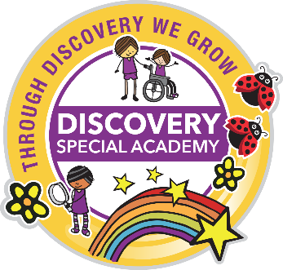
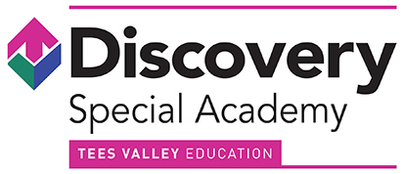

Annual SEND Information Report

2019-20

For further information, go to:
www.discovery.teesvalleyeducation.co.uk

Or contact us at the academy:
Discovery Special Academy, Kedward Avenue, Brambles Farm, Middlesbrough, TS3 0DB
(01642) 248333

Discovery SEND Information Report 2019-2020

Identification of Need
Discovery Special Academy is a co-educational special academy for primary pupils (4 to 11 years) with severe learning difficulties (SLD). Children may also have needs in more than one area such as a physical disability or sensory difficulties. All children who attend have an Education and Health Care Plan (EHCP). The EHCP must identify a pupil’s main presenting needs as learning difficulties; moderate or severe, alongside any other communication difficulties, physical, sensory and medical needs. EHC Plans are created with information from parents, educational staff and other relevant medical staff, such as an Educational Psychologist or a Speech and Language Therapist. The EHCP helps to determine what level of education, social and health support your child needs. Each year we will hold a formal review to assess progress made and update with any amendments or changes. This will be completed in liaison with the relevant local authority. We believe that a child’s education is a partnership between parents, professionals and academy staff, therefore we aim for regular, open and honest communication.
On entry to Discovery, each child is assessed (baseline assessment). Staff continually monitor and assess so we can track your child’s progress over time from their individual starting points.
Before a child starts at Discovery Special Academy, we would aim to complete the following procedures:-
- Receive written information outlining the child’s special educational needs, safeguarding concerns and other relevant history.
- Liaise with the family and relevant professionals involved, to gain expert advice on the child’s needs.
- Visit the child in their current setting (providing this is possible).
- Attend any case reviews or meetings at the child’s current educational setting where decisions on future placements will be discussed.
- Discuss our range of provision with parents/carers so they can make an informed decision on placement.
- Secure all relevant resources in writing prior to admission (this is usually a banding descriptor and funding amount identified by agreement between the academy and LA).
- Secure a home visit by the school nurse and/or SEND Inclusion Officer to identify any medical needs or additional requirements so a detailed care plan is in place on the first day of enrolment.
- Provide several opportunities for the child to visit the academy (with support if necessary) to aid transition into Discovery Special Academy.
- Parents will have received a Discovery Special Academy welcome pack and signed and returned the terms and conditions of accepting a place at the academy, which includes supporting all academy policies.
We place a significant amount time and resources in ensuring our children have the best possible start at Discovery Special Academy, and that parents/carers are reassured their child’s needs will be fully supported from the outset.
In all cases, the LA and academy will work together to ensure that the admission of a child is appropriate for the needs of a child and is not "incompatible with the efficient education of others." [Special Educational Needs and Disability Code of Practice 2015]. The number of available places are limited each year and reviewed in line with required procedures relating to special educational needs to reflect demand for places and to ensure the efficient and effective use of available resources. Consideration will need to be given to available places within the key stage and the needs and dynamics of any class group that may be impacted by the admission.
Curriculum
Curriculum provision at Discovery is dependent on the needs of the child. Therefore, we do not prescribe to one specific teaching approach, as what works for one child may not work for another. This means that we draw on a variety of approaches, including traditional teaching methods for those pupils who are able to access subject specific learning. This allows a holistic approach centred on personalised learning with developmental learning intentions drawn from a variety of sources including (but not limited to) Development Matters, the National Curriculum Frameworks, Occupational Therapy programmes and Speech and Language interventions.
While emphasis will be placed on the progression of all pupils and their academic achievement, this will be realised through a holistic approach to be delivered through the following three areas of development:
- academic curriculum;
- therapeutic input and offer; and
- communication and life skills
High levels of aspiration and achievement will be gained through a multi-sensory based personalised curriculum covering the academic, therapeutic, social, emotional and mental health support. It also supports the physical development of children using movement programmes and drawing on the principles of sensory integration therapy. Professionals will work together to develop the most appropriate curriculum and targets for pupils so that the holistic needs of the child are met daily. Pupils will be taught in creative contexts that expand their horizons and encourage them to demonstrate a range of strengths and skills underpinned by a range of suitable care and medical support and therapies. For pupils with severe and complex SEND this must be an education that is mindful of the individuality of each pupil’s learning difficulty and one that recognises the need for a multi-modal, holistic approach, supported by a range of multi-sensory activities.
In this way, the curriculum is designed around the child rather than trying to fit the pupil into a given curriculum. This means that the teaching approach chosen at any given time in the pupil’s educational journey is entirely fit for purpose. Pupils will be prepared for the next stage in their learning journey and life, with greater levels of independence, effective social skills, good emotional well-being and resilience.
Central to the success of the curriculum at Discovery Special Academy is the integration of therapeutic approaches. These include but are not limited to:
- Makaton
- Symbol exchange communication systems
- Alternative and Augmentative Communication (AAC)
- Intensive Interaction
- Sensory diets and Sensory integration programs (working in partnership with OT)
- Sensory stories and multi-sensory approaches
- Visual supports (timetabling, schedules, key rings)
- Objects of reference
- Inclusive technology (switches, eye gaze)
- Fun with Food
- Proprioceptive massage
- TAC PAC
- SCERTS
- Movement programmes/ Sensory Circuits
- Counselling/play therapy
Accessibility
Currently, Discovery Special Academy is located in temporary accommodation, mainly on the site of Brambles Primary Academy. We regularly use facilities at Pennyman Primary Academy including sensory and soft play facilities. These academies are part of our trust family, Tees Valley Education. All accommodation is on single storey site with ramps, disabled toilets and washing facilities, and are fully wheelchair accessible.
There is disabled parking within the car parks at both sites and all visitors are able to enter via an accessible entrance. Corridors are wide and there are ramps rather than stairs. Disabled toilets are provided and there are fully equipped care rooms at each provision. Both sites have large outdoor play spaces which contain a range of specialist equipment. We provide accessible transport for the children wherever required. Within each classroom there are relevant resources and equipment to enable children to access the curriculum.
All staff and children who require special assistance during emergency evacuation are included in the academy Personal Emergency Evacuation Plan (PEEP). Routine fire and emergency evacuations exercises are held each term. All visitors to the academy (on both sites) must report to the office and wear ID badges for the duration of their visit. Visitors working directly with children must produce a valid Disclosure and Barring certificate to office staff.
Where English is not the first language, the academy supports home/academy relations by utilising interpreters where appropriate. Our website can be translated into a number of languages at the click of a button.
ICT is used to help some of our children access the curriculum; there are interactive white boards, switches, communication aids, Eye Gaze equipment and iPads available throughout the academy.
There are a range of approaches to help develop communication throughout the academy; symbol communication systems, Makaton (sign language), Boardmaker (to create symbols to support reading and vocabulary), Eyegaze (to support students to communicate through eye movement) and Objects of reference (used to support early communication where an object represents a place or event that is important to the child).

Soft play area Sensory room
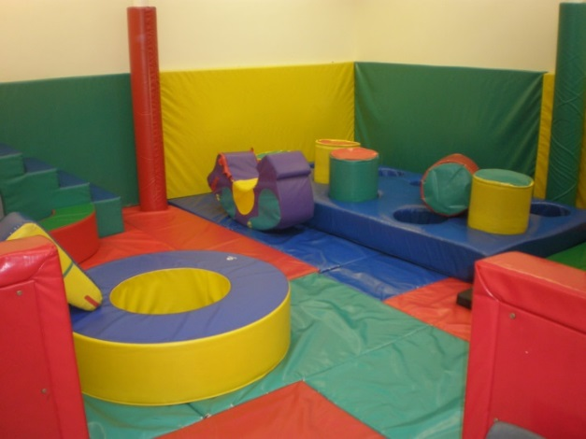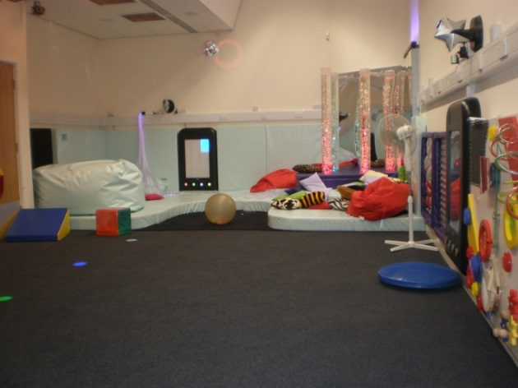

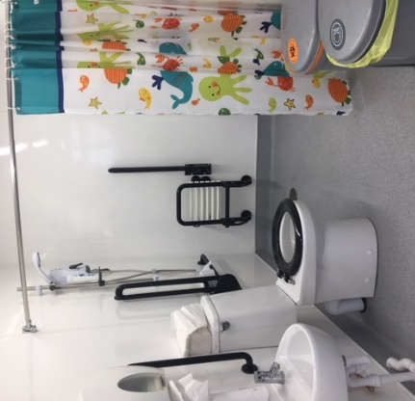
2 x Healthcare / Changing / Therapy rooms
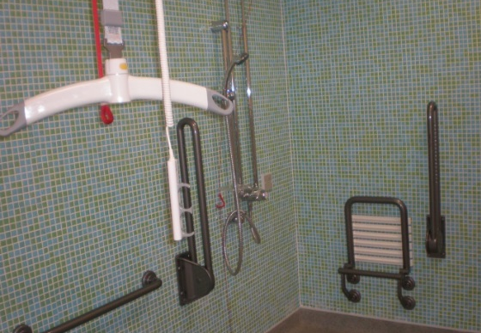
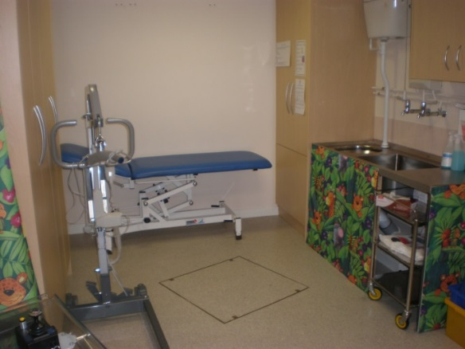 Wet rooms

Support
The first point of contact is the class teacher. Teachers have overall responsibility for the welfare of the children in their class. They are supported in this role by the senior leadership team and a range of other professionals; we are committed to multi-agency working to ensure the needs of the whole child are met. Class teachers are supported by teaching assistants. Care assistants are employed to support the personal needs of the children.
All children have a care plan which identifies personal care needs, dietary requirements and administration of medication where appropriate.
On site medical support is provided by the School Nursing Service by arrangement. Professionals from other agencies such as physiotherapy, occupational therapy and Speech and Language support visit the academy on a regular basis. These professionals support individual children offering advice and training to staff.
Discovery Special Academy works closely with the following agencies:
- Middlesbrough SEND team
- Redcar and Cleveland SEND team
- Educational Psychology
- Speech and Language
- CAMHS
- Occupational therapists (Tree Tops)
- Physiotherapists
- Play therapist
- Social services
- Community nursing
- REACH
- Harbour
- VI/HI services
- Children Looked After
- Orthotics
- Continence
- Wheelchair clinic
- Dieticians
Our Pastoral and Welfare officer provides support to parents, liaises between home/academy and monitors attendance. The academy works closely with Social Services. Workshops/drop-ins by outside agencies (such as Citizens Advice Bureau) are held termly. We have clear referral routes to external agencies which include the Sensory Impaired Service (HI & VI), Social Care, CAMHS, Forget me Not, Banardos, Welfare Support, Housing, Grants and Benefits. In addition, support and guidance from charitable organizations are signposted.
Home/academy diaries are used regularly. A newsletter is sent home each term and assessment information is shared. We also use an App called Marvellous Me to celebrate the children’s success.
The pastoral team meet regularly to ensure the pastoral needs of children are met. Pupil voice is encouraged in all areas and there are regular student council meetings (where appropriate). Children are informed about what bullying is and ways in which it can be dealt with. We log all incidents of bullying and although this is extremely rare, there is an option for restorative justice sessions.
Children who are Looked After have access to all of the resources open to other children and in addition, regular review and monitoring meetings are held. We collect data on progress and attendance to ensure their performance is line with their peers.
Parental involvement
Parents are always encouraged to support their child’s learning at home. Parental workshops are held during the academic year. Parents are invited termly to open events to meet staff and look at children’s work, as well as attending parent/teacher meetings and receiving a detailed pupil report. Discovery regularly invites parents to share a range of events and activities which include performances, celebrations, concerts, coffee mornings, fairs and exhibitions. Parents are also invited to the annual EHCP review.
Staff training
All teachers have qualified teaching status and teaching assistants have a minimum of a level 3 qualification or equivalent. We have a comprehensive induction programme for all staff to ensure all are trained in pediatric first aid including epilepsy, anaphylaxis, asthma and diabetes. They are also trained in positive handling, manual handling, safeguarding, PREVENT, tube feeding and fire awareness. Staff training is ongoing to ensure we meet the educational needs of all our children and stay up to date with current research into teaching and learning. As part of Tees Valley Education Trust, staff share best practices from four academies as well as having access to our own central improvement team. Staff access training relevant to their roles and career stage, for example, middle leadership training or subject based training. All staff receive at least 5 days CPD per year.
Activities outside of the academy
Discovery are committed to providing opportunities for children to have equal access to an enriched and extended curriculum. A variety of activities are provided in the academy such as hydrotherapy, rebound, art, dance, music, cookery. Trips to local theatres, galleries, historic sites, parks, etc. are part of the curriculum too. We also provide many opportunities at the academy to widen cultural experiences, such as visiting musical groups or ZooLab, for example.
Our Pastoral and Welfare Officer will keep parents up to date with suitable activities happening in the local area including after school and holiday clubs.
Transition
Transition arrangements are made on an individual basis for each child and in discussion with parents and professionals from previous provisions; this is to reduce children (and parents!) anxiety levels. Admission for children is usually in September into Reception but can occur at various stages of their education. In the main, children come from the Cleveland Child Development and Assessment Unit. For all, we ensure a comprehensive transition programme which includes visits from the senior leadership team to meet the new children, and regular visits by the new children to meet us in the academy. Parents are welcomed to look around the academy and attend a coffee morning/afternoon in order to meet the team who will be working with the child and gather vital information.
Likewise, when a child transitions to another provision, arrangements will be made to best suit the child and will be done collaboratively with parents and all professionals involved.
Transport
Home to academy transport is provided for all eligible children by the local authority. The majority of children travel to and from the academy in a mini bus or taxi and are accompanied by a passenger assistant/escort.
Further details regarding transport can be obtained by:
Middlesbrough transport department (01642) 353447
Redcar & Cleveland transport department (01642) 444973
SEND resources
The academy receives base funding for each child in the academy and a ‘top-up’ element based on the child’s personal level of need. Resources are allocated according to the assessed need and is reviewed on a regular basis.
Linked policies & documents (all available at www.discoveryspecialacademy.org.uk)
SEND Policy
Admissions Policy
Attendance Policy
Child Protection and Safeguarding Policy
Positive Behaviour Policy
Equality Policy & Equality objectives
Accessibility Plan
Health & Safety Policy
Supporting children with medical needs & life threatening illness Policy
Intimate Care policy
Graduated Response
Pupil Premium Grant policy
Other policies and guidance documents
DfE – Supporting pupils at school with medical conditions (December 2015)
DfE SEND Code of Practice (2014)
DfE School Admissions Code (2014)
Children & Families Bill (2013)
Further information
Middlesbrough council website is www.middlesbrough.gov.uk
Middlesbrough Special Educational Needs Service (01642)
Redcar and Cleveland Council website is http://www.redcar-cleveland.gov.uk
Redcar and Cleveland Special Educational Needs Service (01642) 304561/304503
Local Authority & Health Authority
Middlesbrough Council Children with Disabilities Team 579161
Redcar & Cleveland Council Children with Disabilities Team 304500
Middlesbrough LA SEN Team 201828
Redcar & Cleveland LA SEN Team 304511
Middlesbrough LA Parent Partnership Officer 201872
Redcar & Cleveland LA Parent Partnership Officer 837745
The Cleveland Child Assessment Unit – JCUH 854288
Service for Children with Visual Impairment 354353
Service for Children with Hearing Impairment 354353
Middlesbrough Welfare Rights Service 729242
Redcar & Cleveland Welfare Rights Service 771166
Physiotherapy / Occupational Therapy Service 873901
Speech & Language Therapy Service 246603
Charities & support organisations
In Control 01564 821650
Contact a Family 0808 808 3555
Whizz Kidz 01642 276251
Jack in the Box (R&C) 01642 384091
Council for Disabled Children 0207 843 1900
The Parents Carers Alliance (R&C) www.TPACA.co.uk
Parents 4 Change (Middlesbrough) 01642 200526
MAIN Project (Autism support) 01642 608012
SCOPE 0808 800 3333
Mencap 0808 808 1111
Disability Rights UK 0800 328 5050
Family Action 020 72546251
MIND (Mental Health) 020 8519 2122
Barnado’s (North East) 0191 240 4801
Forget Me Not (Teesside Hospice Child Bereavement) 01642 811063
I-Can (Children’s Communication) 020 7843 2544

