Uniform
We believe that wearing a uniform helps promote a strong sense of identity and creates pride in the children and their academy. It makes them feel part of our academy family.
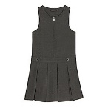
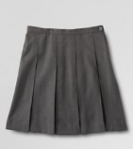
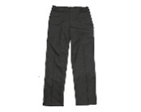
The uniform consists of:-
- Grey/black skirts, pinafores or trousers

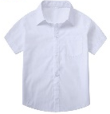
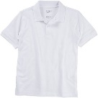
- White or purple polo shirt
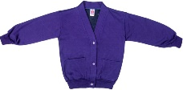
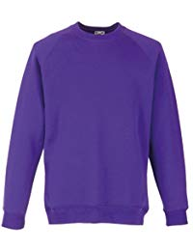
- Purple sweatshirt or cardigan
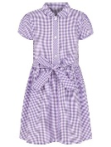
- Purple and white gingham dress
which can be worn in the summer
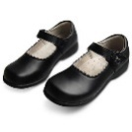
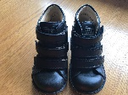
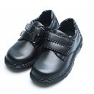
- Black sensible shoes. For those who wear
orthopaedic shoes or boots (such as Piedro),
these should also be black.
The PE uniform consists of:-
- Pair of shorts or jogging bottoms
- T-shirt
- Black plimsolls or trainers
Uniforms and PE kits are available to order from the academy office or can be placed directly with our supplier, please ask the office for further information or use the contact details below. The sale of uniforms is a non-profit making venture.
Jewellery is not allowed in the academy, however, if your child has pierced ears they should wear small studs and these should not be worn on days your child has PE.
Lollipops
Lollipops
20 Norfolk Place
Berwick Hills
Middlesbrough
TS3 7PA
Tel: 01642 225827
http://lollipops-middlesbrough.co.uk/school-uniform/school-uniform-lists/discovery-special-academy/

