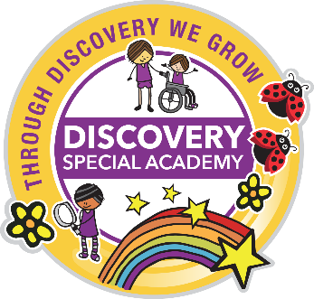
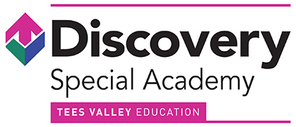

Annual SEND Information Report

2025-2026

For further information, visit:

www.discovery.teesvalleyeducation.co.uk

Or contact us at the academy:

Discovery Special Academy, Sandy Flatts Lane, Middlesbrough TS5 7YN
(01642) 248333

Discovery SEND Information Report 2025-2026

Identification of Need

Discovery Special Academy is a co-educational special academy for nursery, primary and secondary pupils (3 to 16 years) with severe learning difficulties (SLD). Pupils may also have needs in more than one area such as a physical disability or sensory difficulties. All pupils who attend the primary and secondary setting have an Education and Health Care Plan (EHCP). The academy also has a twelve-place assessment nursery, pupils are placed on assessment by the local authority and the academy processes the EHCPs if they do not already have one.
To be admitted to the academy, the EHCP must identify severe learning difficulties, alongside any other communication difficulties (including Autism), physical, sensory and medical needs. EHC Plans are created with information from parents, educational staff and other relevant medical staff, such as an Educational Psychologist or a Speech and Language Therapist. The EHCP helps to determine what level of education, social and health support your child needs. Each year we will hold a formal review to assess progress made and update with any amendments or changes. This will be completed in liaison with the relevant local authority. We believe that a child’s education is a partnership between parents, professionals and academy staff, therefore we aim for regular, open and honest communication.
On entry to Discovery, each child is assessed (baseline assessment). Staff continually monitor and assess so we can track your child’s progress over time from their individual starting points.
Before a child or young person starts at Discovery Special Academy, we would aim to complete the following procedures: -
- Receive written information outlining the pupil’s special educational needs, safeguarding concerns and other relevant history.
- Liaise with the family and relevant professionals involved, to gain expert advice on the pupil’s needs.
- Visit the pupil in their current setting (providing this is possible).
- Attend any case reviews or meetings at the pupil’s current educational setting where decisions on future placements will be discussed.
- Discuss our range of provision with parents/carers so they can make an informed decision on placement.
- Secure all relevant resources in writing prior to admission (this is usually a banding descriptor and funding amount identified by agreement between the academy and LA).
- If appropriate, secure a home visit by the school nurse and/or SEND Inclusion Officer to identify any medical needs or additional requirements so a detailed care plan is in place on the first day of enrolment.
- Provide several opportunities for the child/young person to visit the academy (with support if necessary) to aid transition into Discovery Special Academy.
- Parents will have received a Discovery Special Academy welcome pack and signed and returned the terms and conditions of accepting a place at the academy, which includes supporting all academy policies.

We place a significant amount of time and resources in ensuring our pupils have the best possible start at Discovery Special Academy, and that parents/carers are reassured their child’s needs will be fully supported from the outset.
In all cases, the LA and academy will work together to ensure that the admission of a child is appropriate for the needs of a child and is not "incompatible with the efficient education of others." [Special Educational Needs and Disability Code of Practice 2015]. The number of available places are limited each year and reviewed in line with required procedures relating to special educational needs to reflect demand for places and to ensure the efficient and effective use of available resources. Consideration will need to be given to available places within the key stage and the needs and dynamics of any class group that may be impacted by the admission.

Curriculum

Curriculum provision at Discovery is dependent on the needs of the pupil. Therefore, we do not prescribe to one specific teaching approach, as what works for one child may not work for another. This means that we draw on a variety of approaches, including traditional teaching methods for those pupils who can access subject specific learning. This allows a holistic approach centred on personalised learning with developmental learning intentions drawn from a variety of sources including (but not limited to) Development Matters, the National Curriculum Frameworks, the Autism Education Trust, the Engagement Model, MAPP, Occupational Therapy programmes and Speech and Language interventions.

While emphasis will be placed on the progression of all pupils and their academic achievement, this will be realised through a holistic approach to be delivered through the following three areas of development:
- academic curriculum;
- therapeutic input and offer; and
- social and emotional needs, communication and life skills

High levels of aspiration and achievement will be gained through a multi-sensory based personalised curriculum that is mindful of the individuality of each pupil’s learning difficulty covering the academic, therapeutic, social, emotional and mental health support. It also supports the physical development of pupils using a variety of movement programmes and drawing on the principles of sensory integration therapy. Professionals will work together to develop the most appropriate curriculum and targets for pupils so that the holistic needs of the child are met daily. Pupils will be taught in creative contexts that expand their horizons and encourages them to demonstrate a range of strengths and skills underpinned by a range of suitable care and medical support and therapies.
In this way, the curriculum is designed around the pupil rather than trying to fit the pupil into a given curriculum. This means that the teaching approach chosen at any given time in the pupil’s educational journey is entirely fit for purpose. Pupils will be prepared for the next stage in their learning journey and adulthood, with greater levels of independence, effective social skills, good emotional well-being and resilience.
Ordinarily available provision:
- Specialist teaching and support staff
- Personalised planning for each pupil
- Small group teaching and 1:1 teaching as needed
- Personalised timetables as needed
- Sensory integration – timetabled and in response to presenting need
- Symbol exchange
- Visual supports (incl. timetables, schedules, now and next)
- Objects of reference
- Makaton
- Communicate in Print used on all resources, displays etc
- Communication supports in classrooms and other areas of the academy
- Focus on preparing for adulthood themes
- Speech and language interventions
- Strategies to support independence
Central to the success of the curriculum at Discovery Special Academy is the integration of therapeutic approaches. These include but are not limited to:
- Intensive Interaction
- Rebound Therapy
- Sensory diets and Sensory integration programmes (working in partnership with OT)
- Sensory stories and multi-sensory approaches
- Inclusive technology
- Proprioceptive massage
- TAC PAC
- Movement programmes/ Sensory Circuits
- Zones of Regulation
- Counselling/play therapy
- ELSA
Accessibility
Discovery Special Academy is located in single site accommodation based at Sandy Flatts Lane. All accommodation is on single storey site with ramps, disabled toilets and changing and hygiene g facilities, and are fully wheelchair accessible.

There is disabled parking within the car park and all visitors are able to enter via an accessible entrance. Corridors are wide and there are ramps rather than stairs. Disabled toilets are provided and there are fully equipped care rooms. There are large outdoor play spaces which contain a range of specialist equipment. We provide accessible transport for the pupils wherever required. Within each classroom there are relevant resources and equipment to enable pupils to access the curriculum.

All staff and pupils who require special assistance during emergency evacuation are included in the academy Personal Emergency Evacuation Plan (PEEP). Routine fire and emergency evacuations exercises are held each term. All visitors to the academy must report to the office and wear ID badges for the duration of their visit. Visitors working directly with pupils must produce a valid Disclosure and Barring certificate to office staff.

Where English is not the first language, the academy supports home/academy relations by utilising interpreters where appropriate. Our website can be translated into a number of languages at the click of a button.

ICT is used to help some of our pupils access the curriculum; there are interactive white boards, switches, communication aids and iPads available throughout the academy.

There are a range of approaches to help develop communication throughout the academy; Symbol Exchange Communication System, Makaton (sign language), Communicate in Print (to create symbols to support reading and vocabulary) and Objects of reference (used to support early communication where an object represents a place or event that is important to the child).

Sensory integration Environments

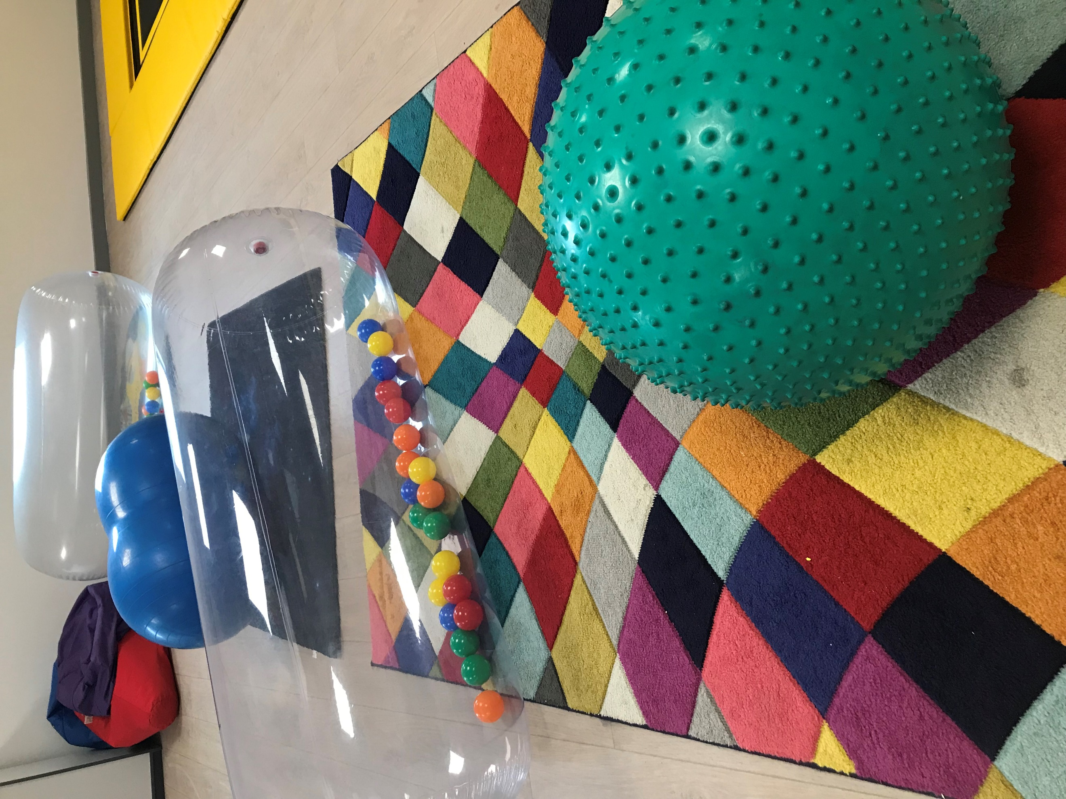
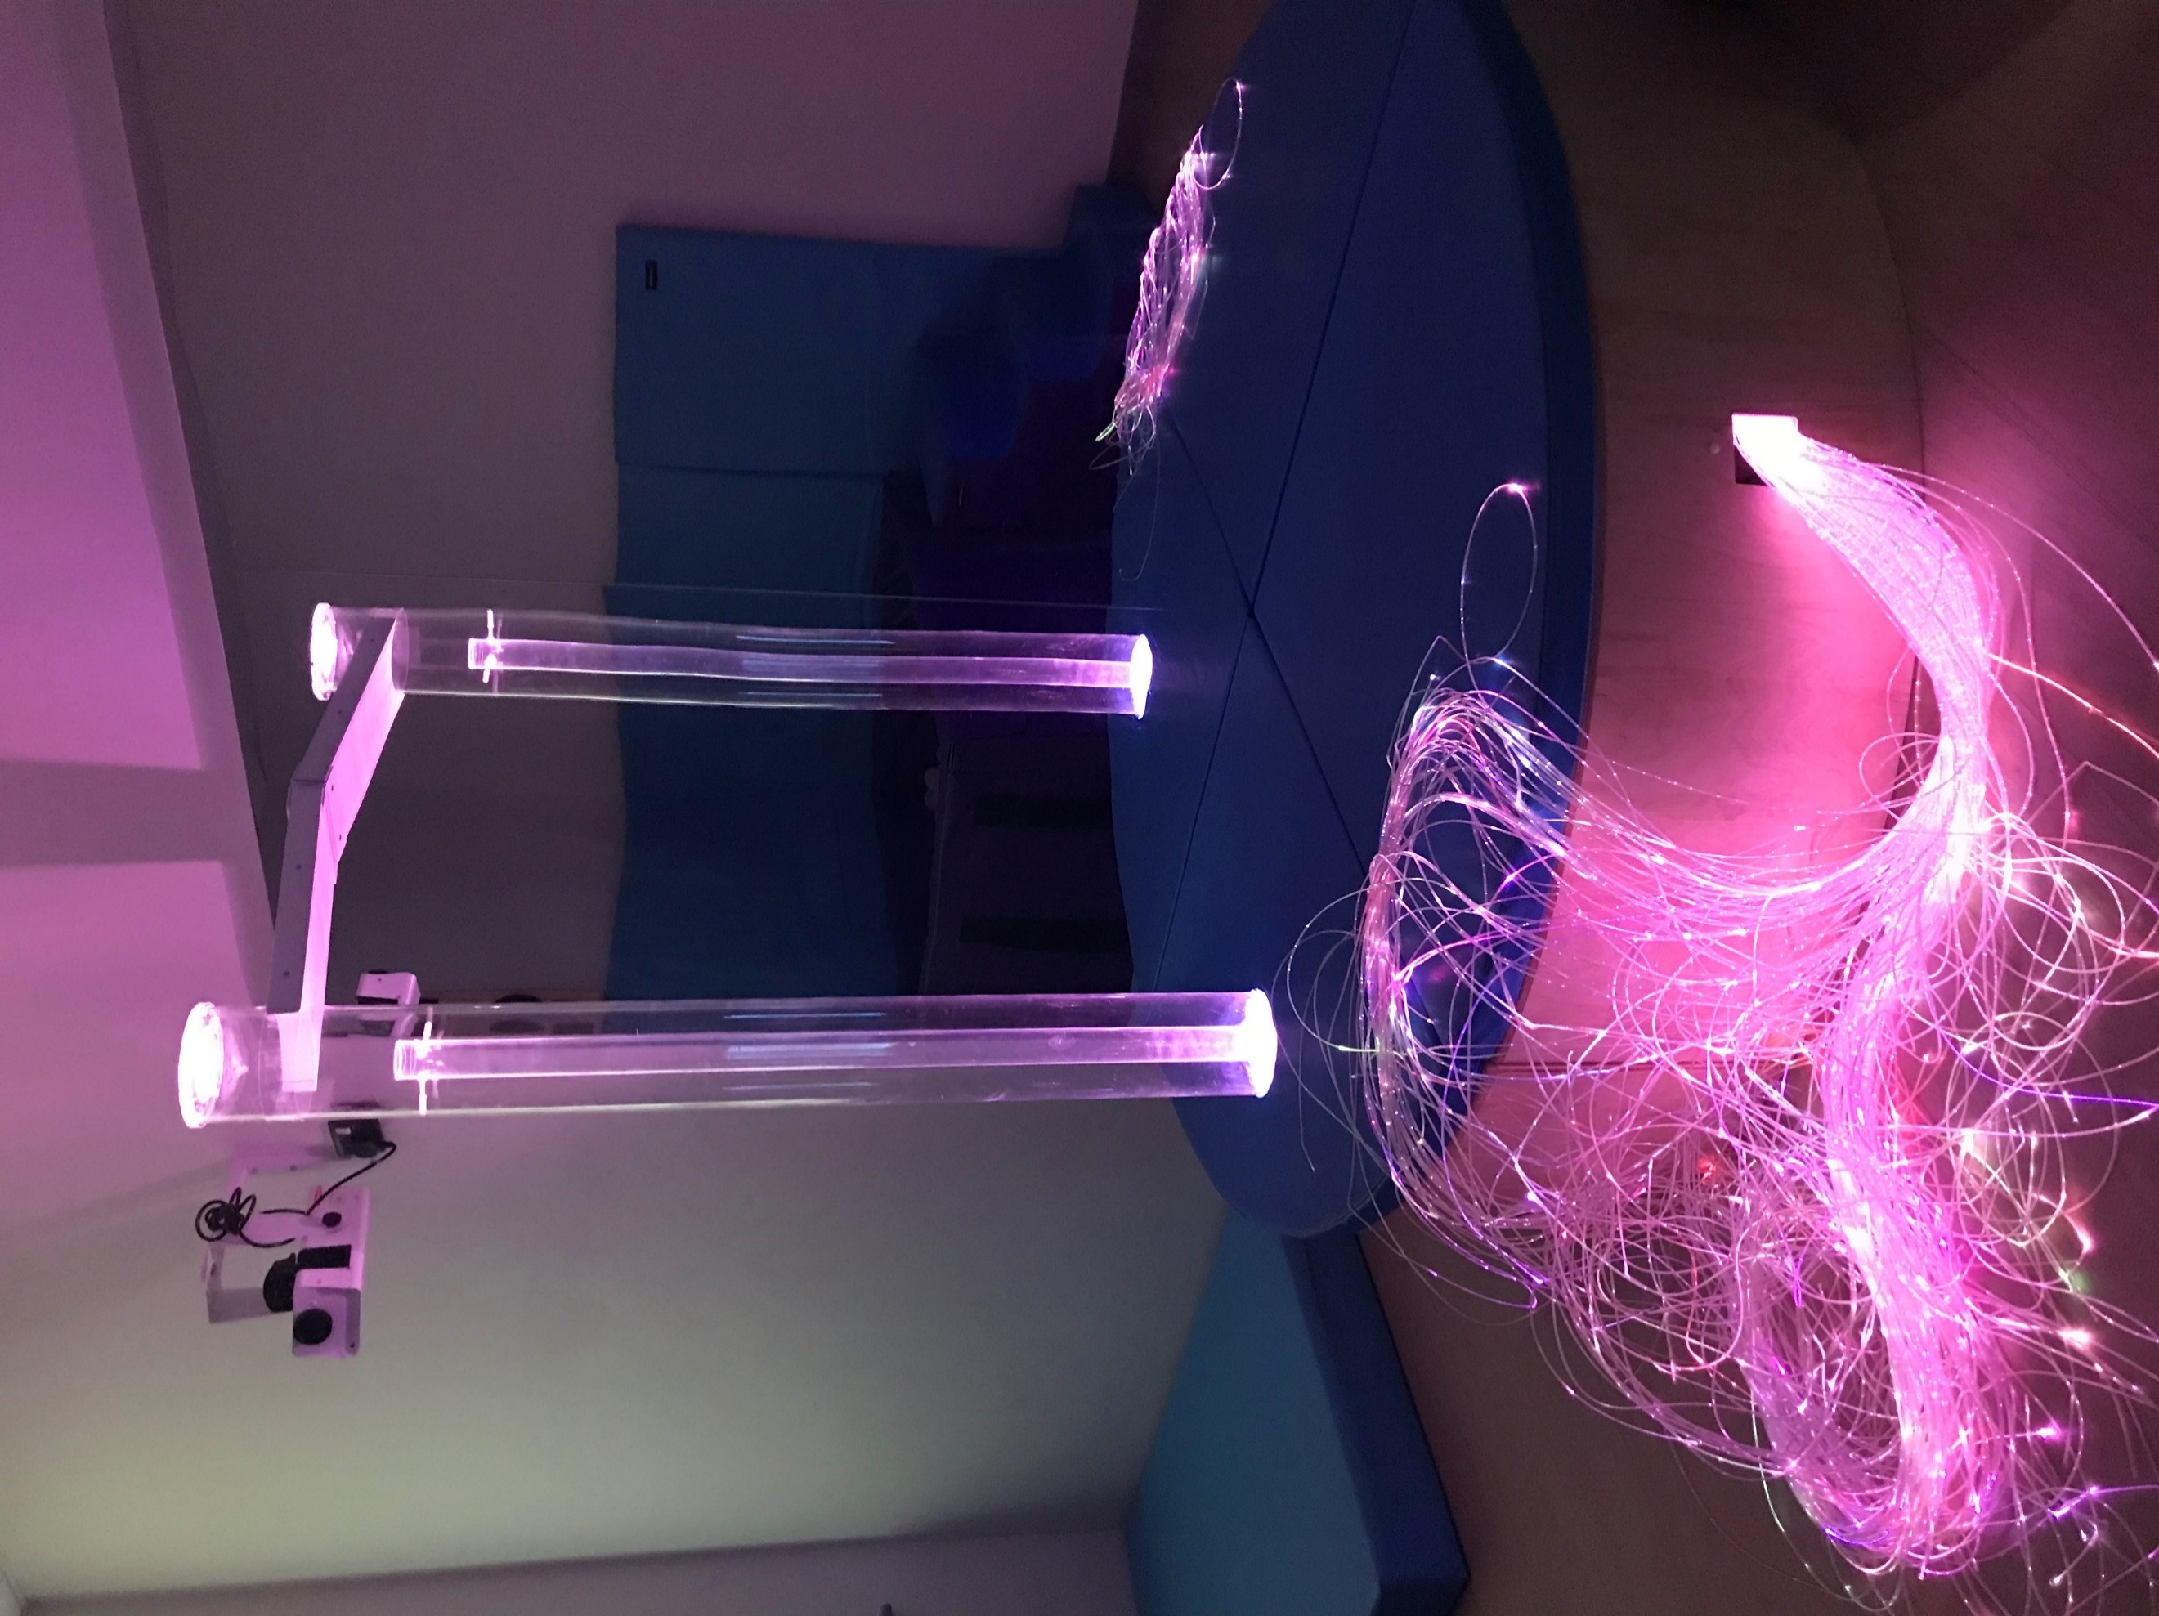
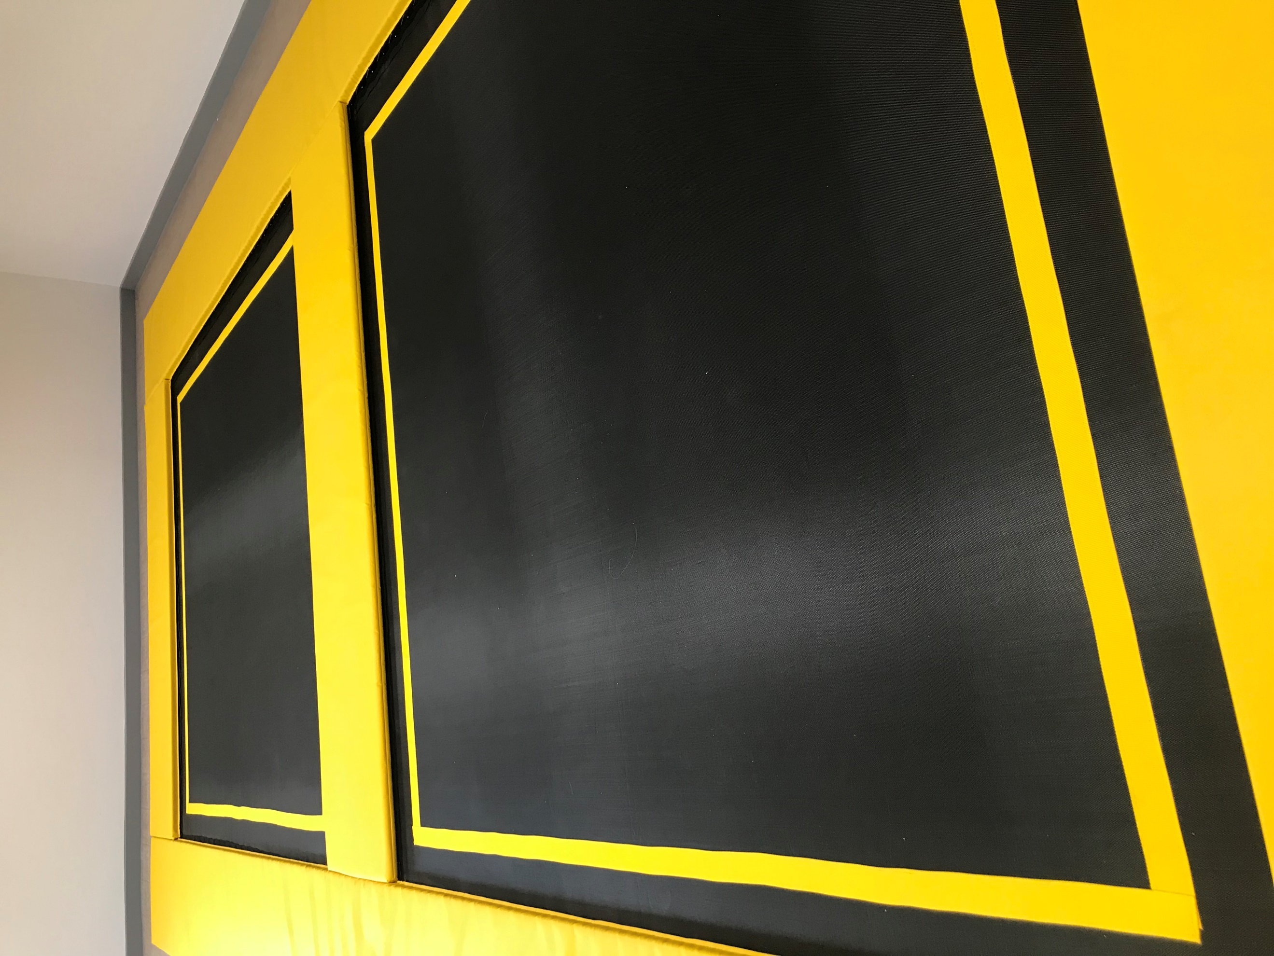

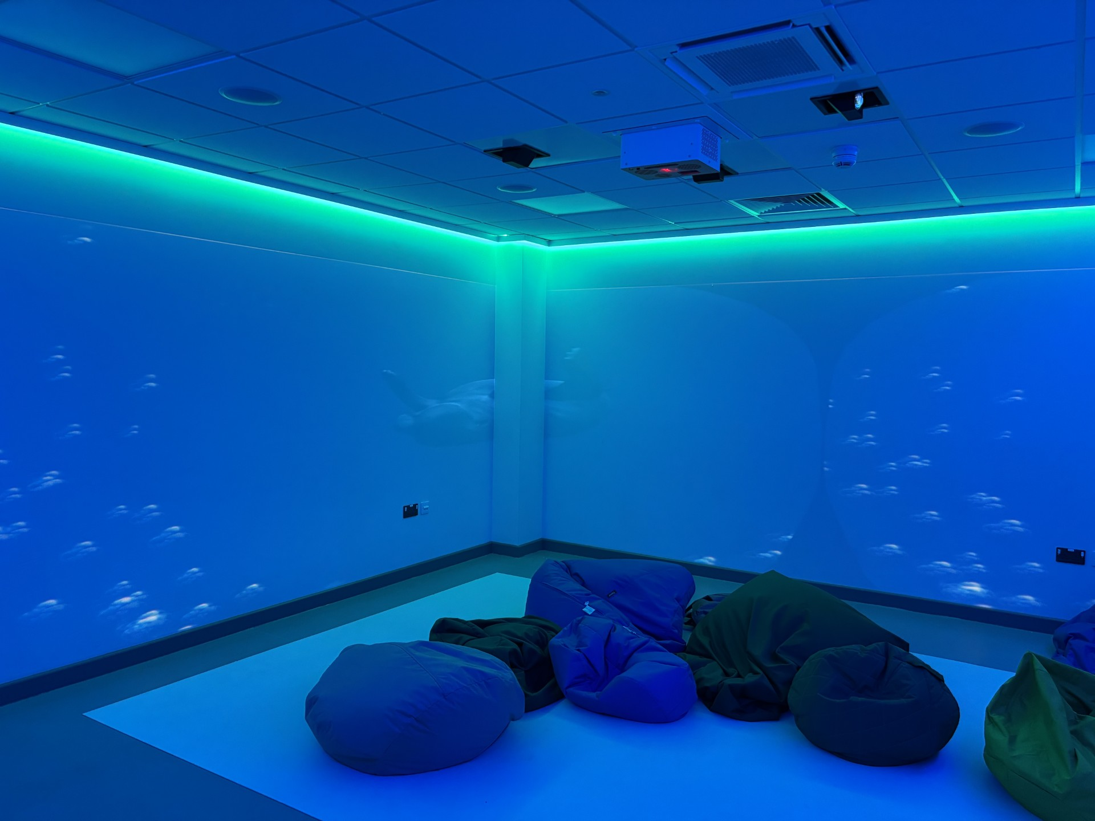

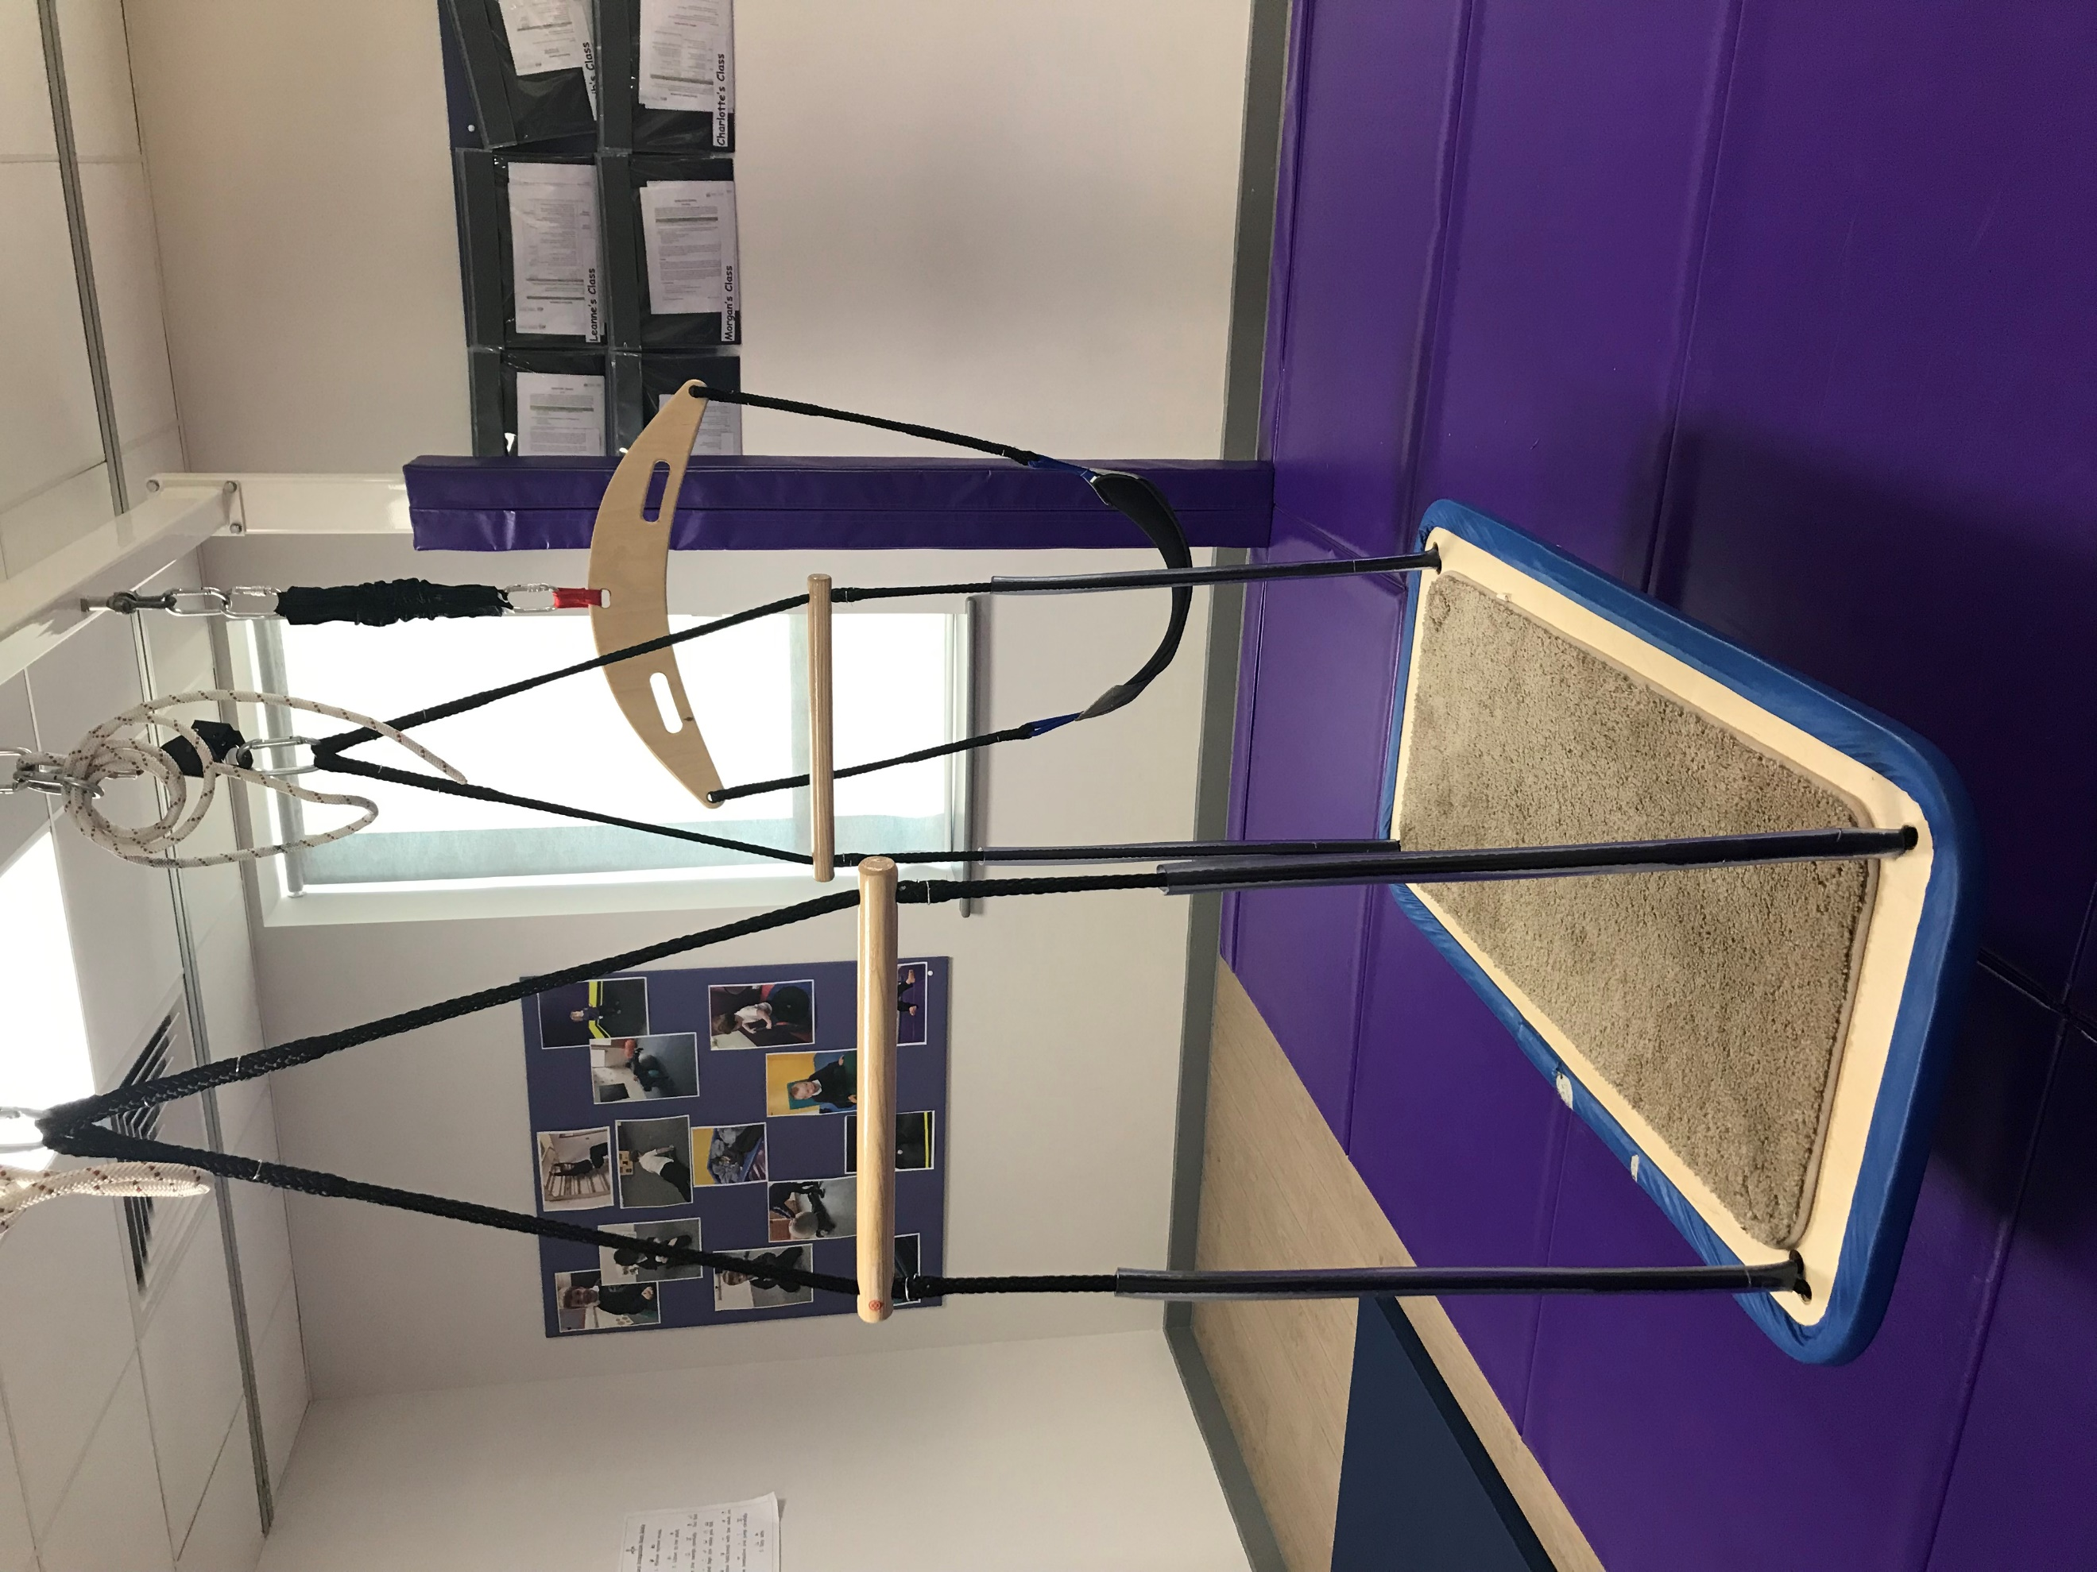

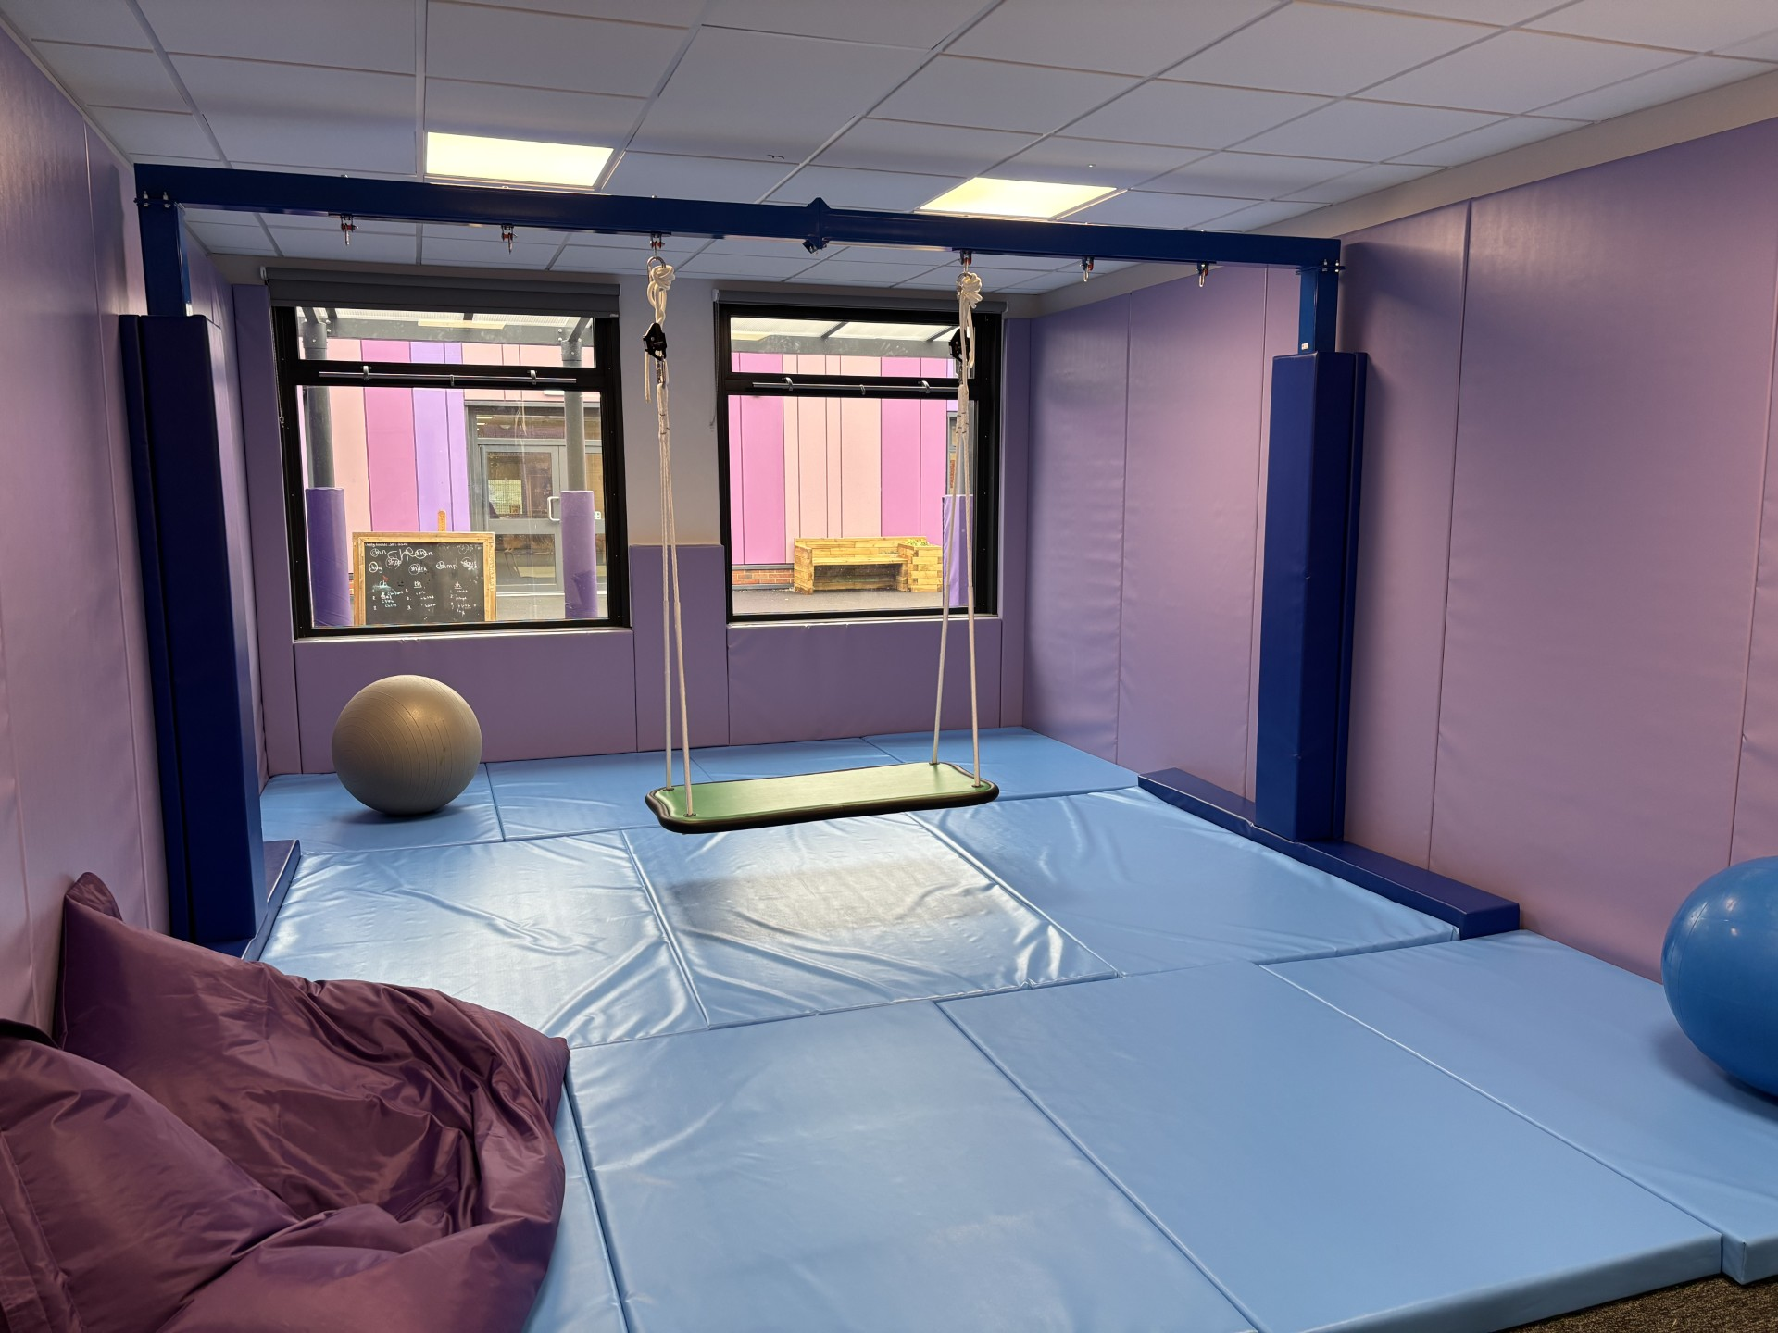

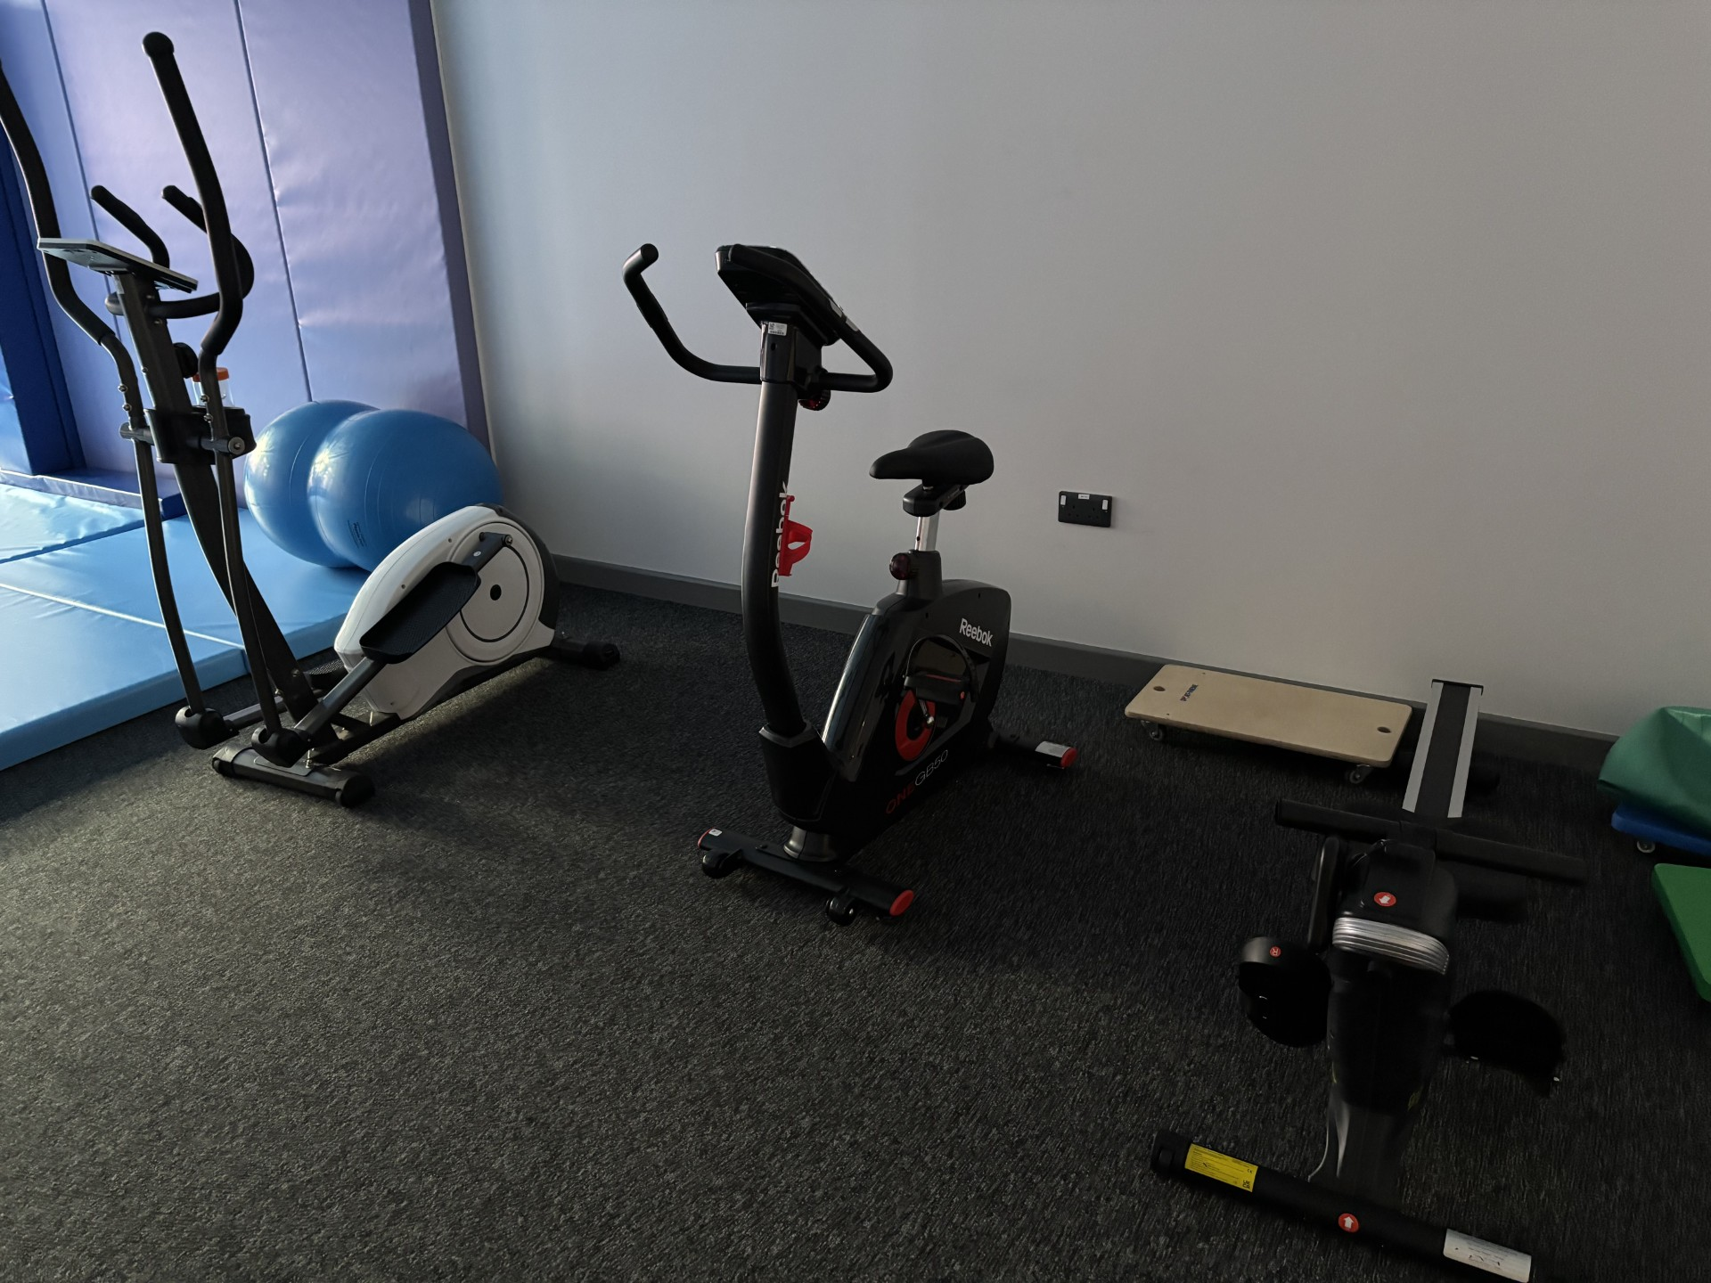

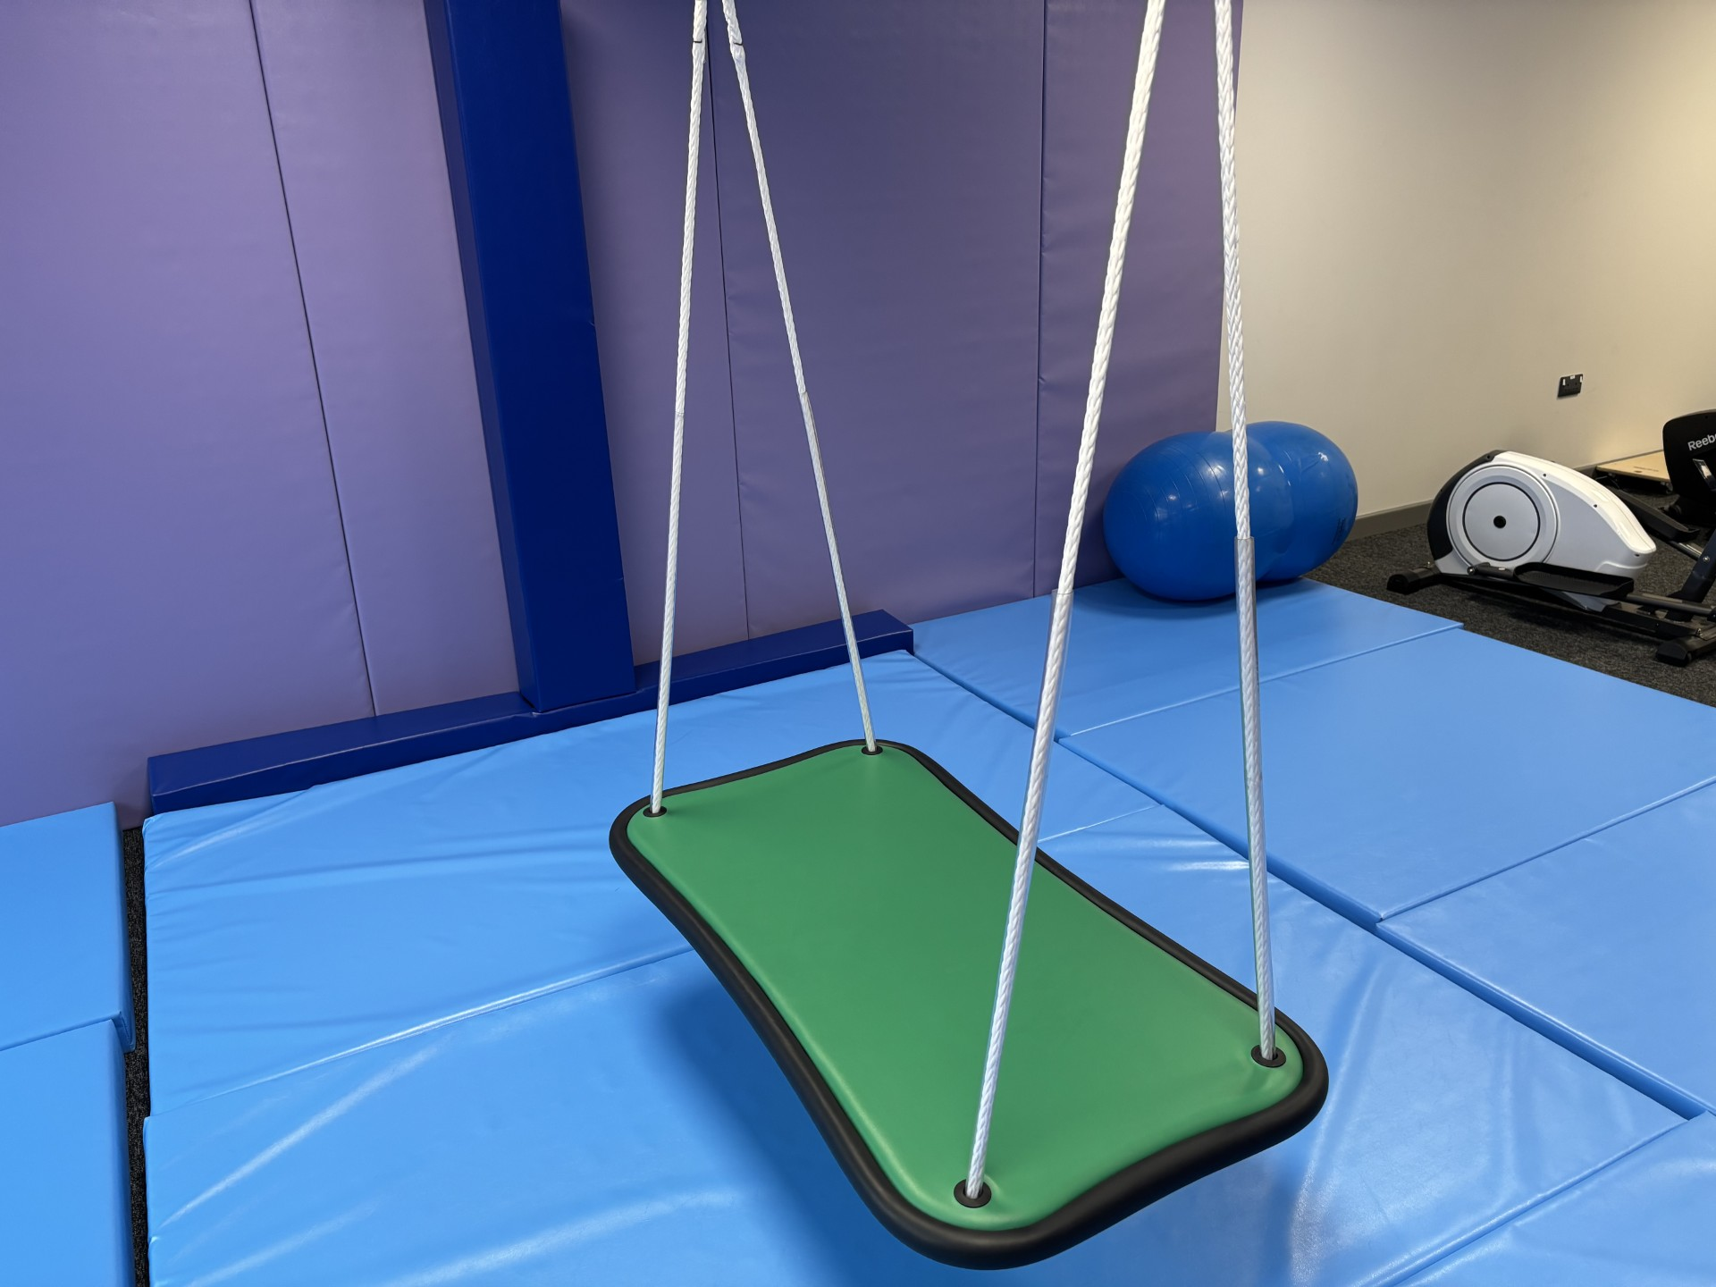
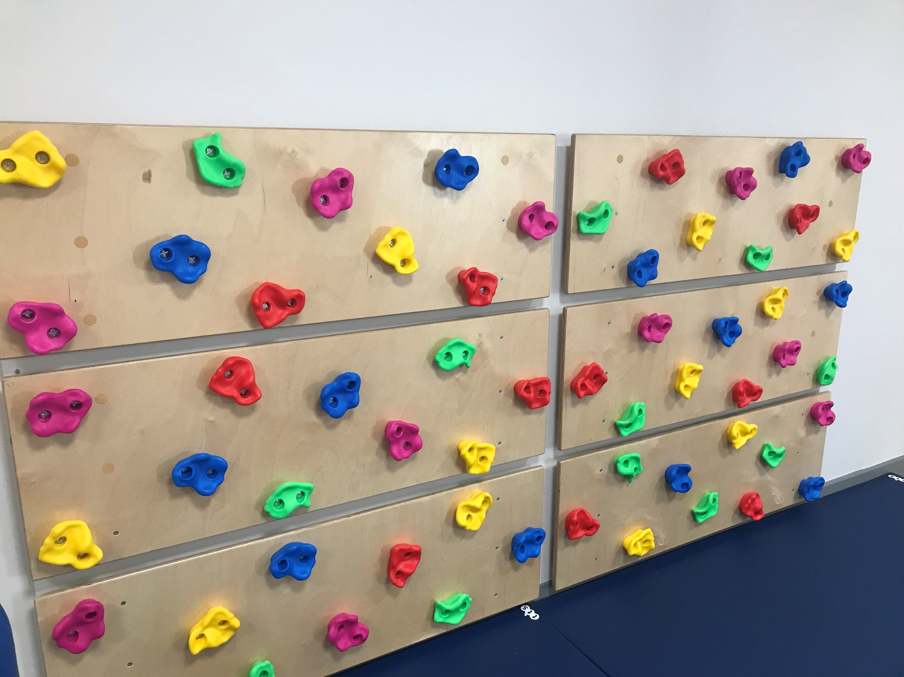
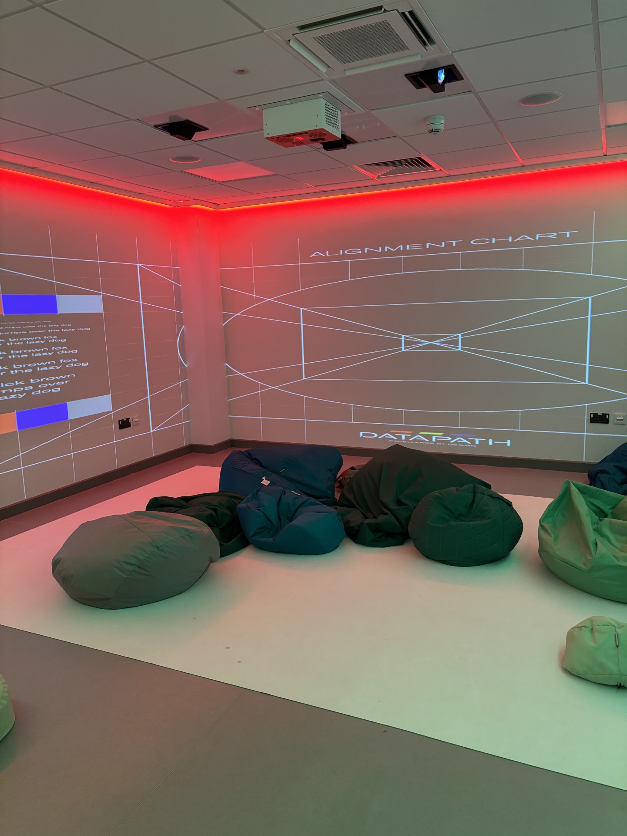

Multi-sensory environments

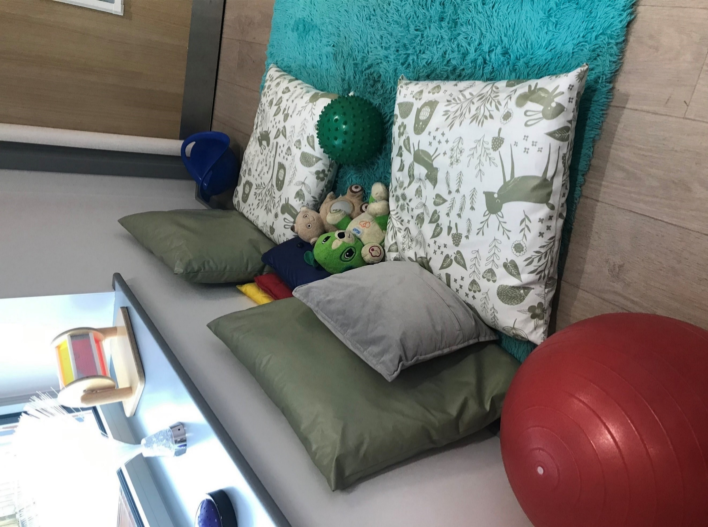
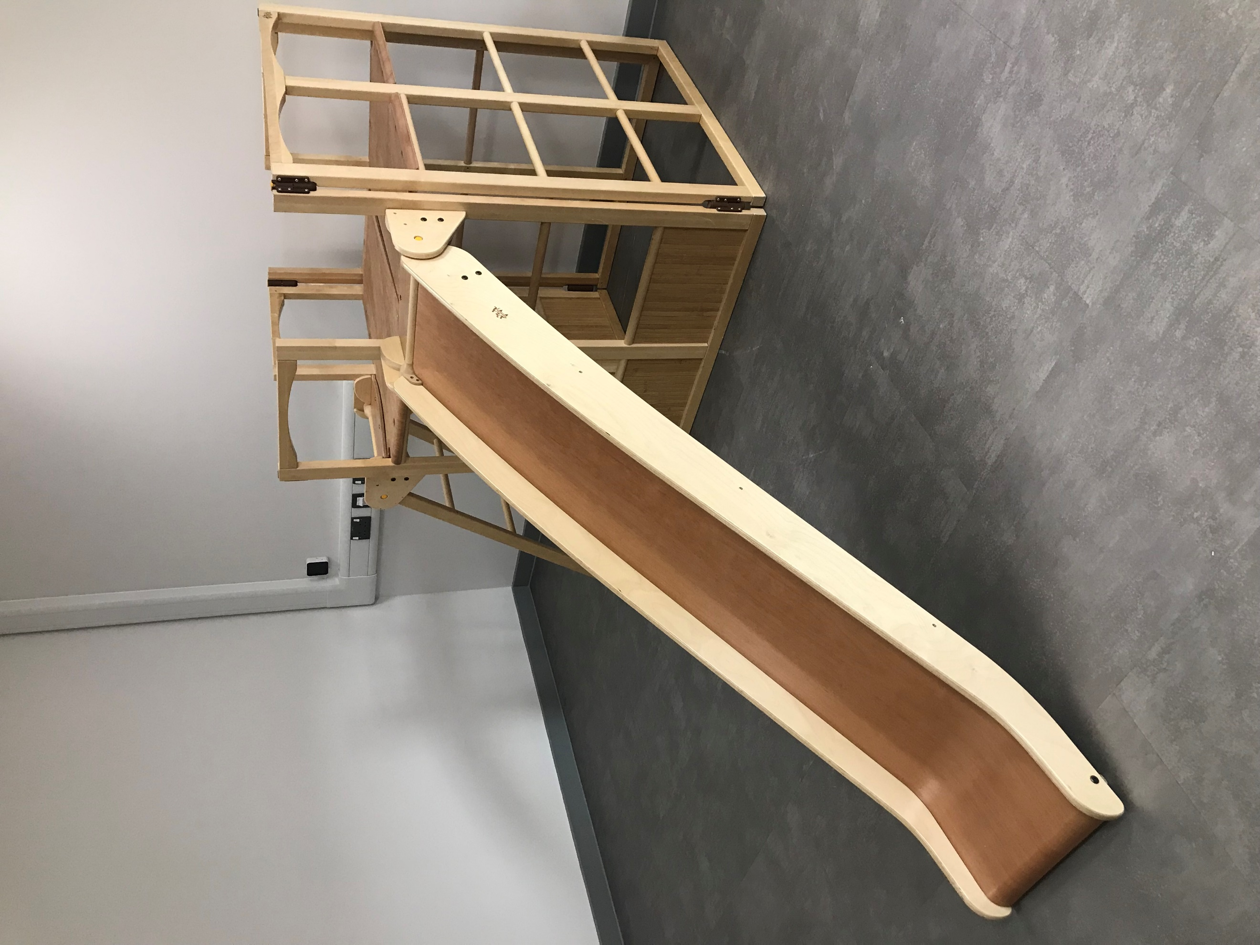
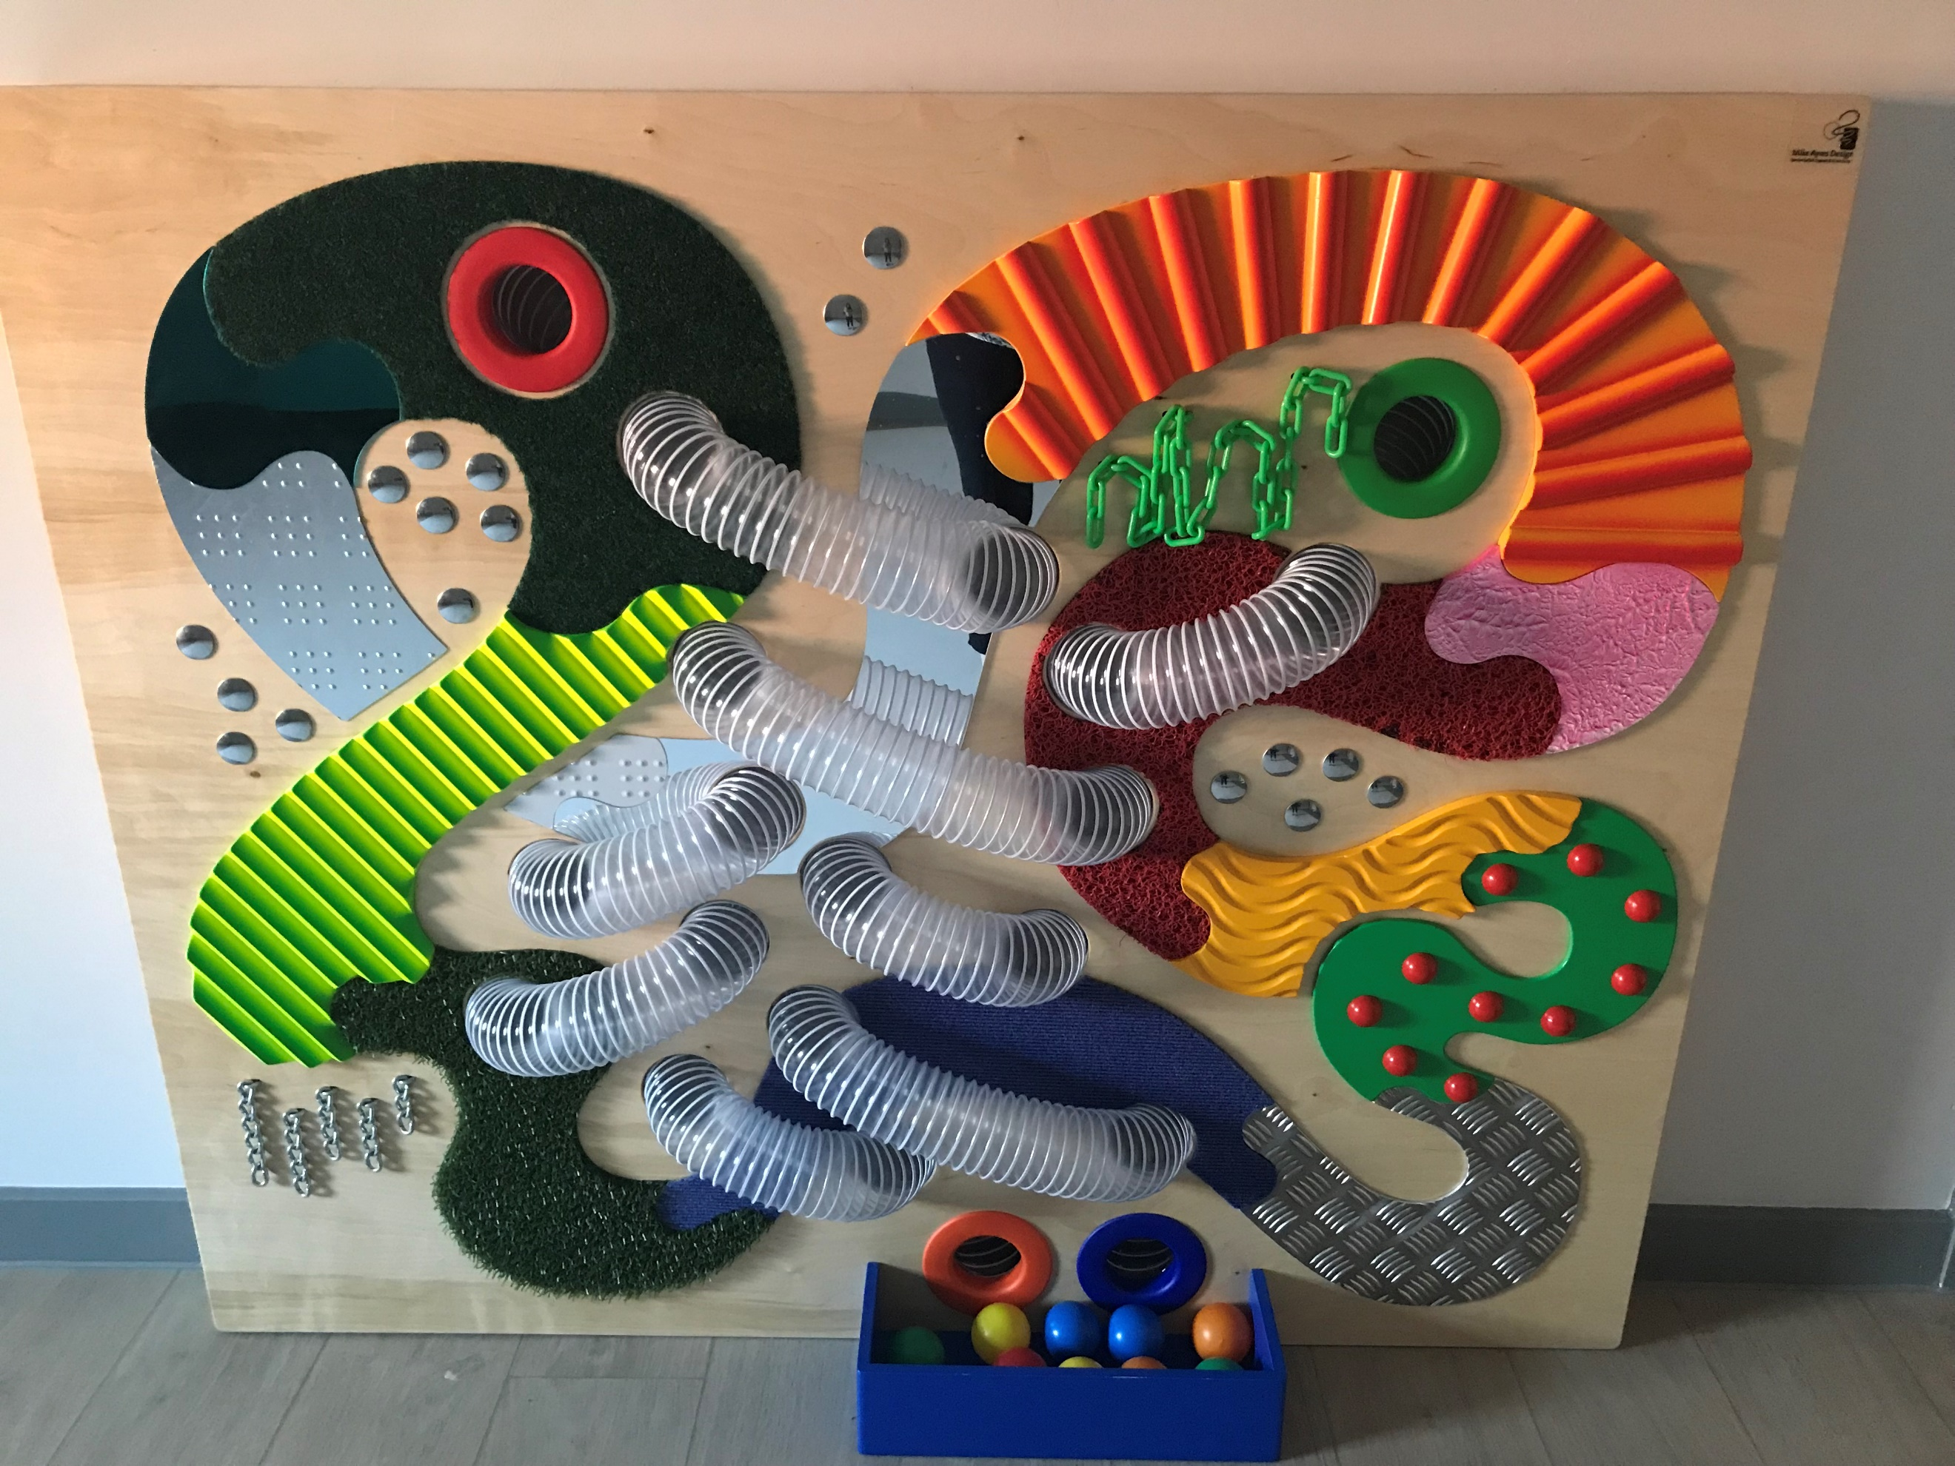

Care and changing rooms

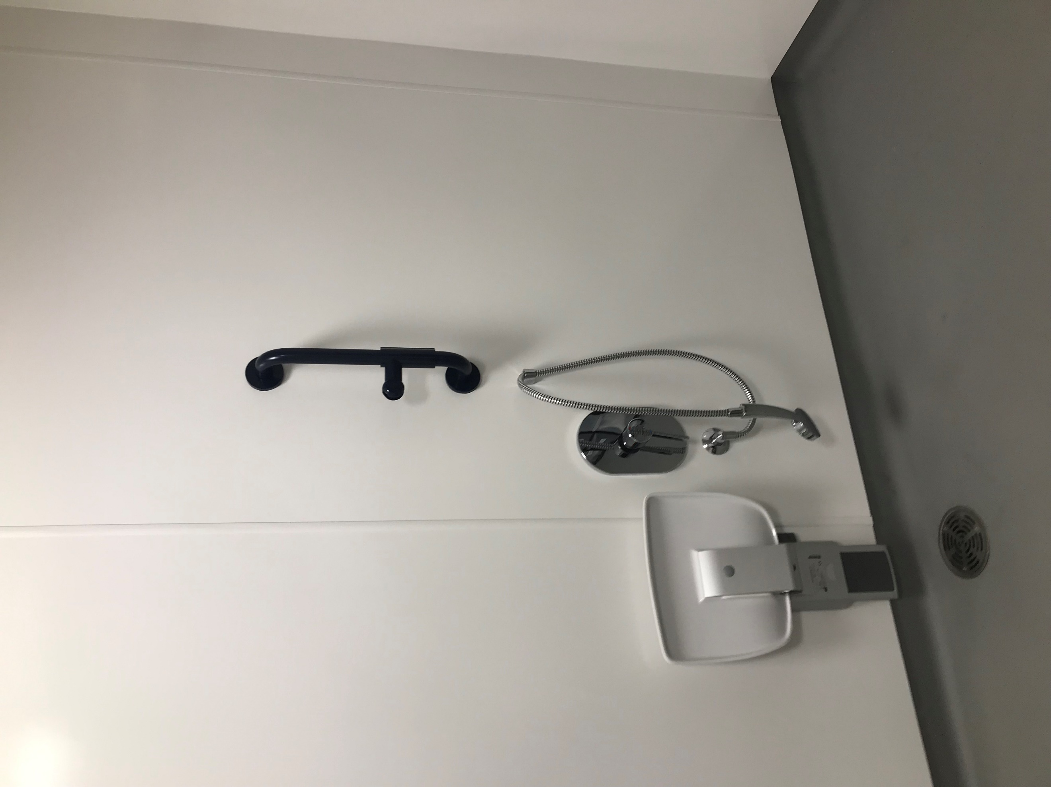
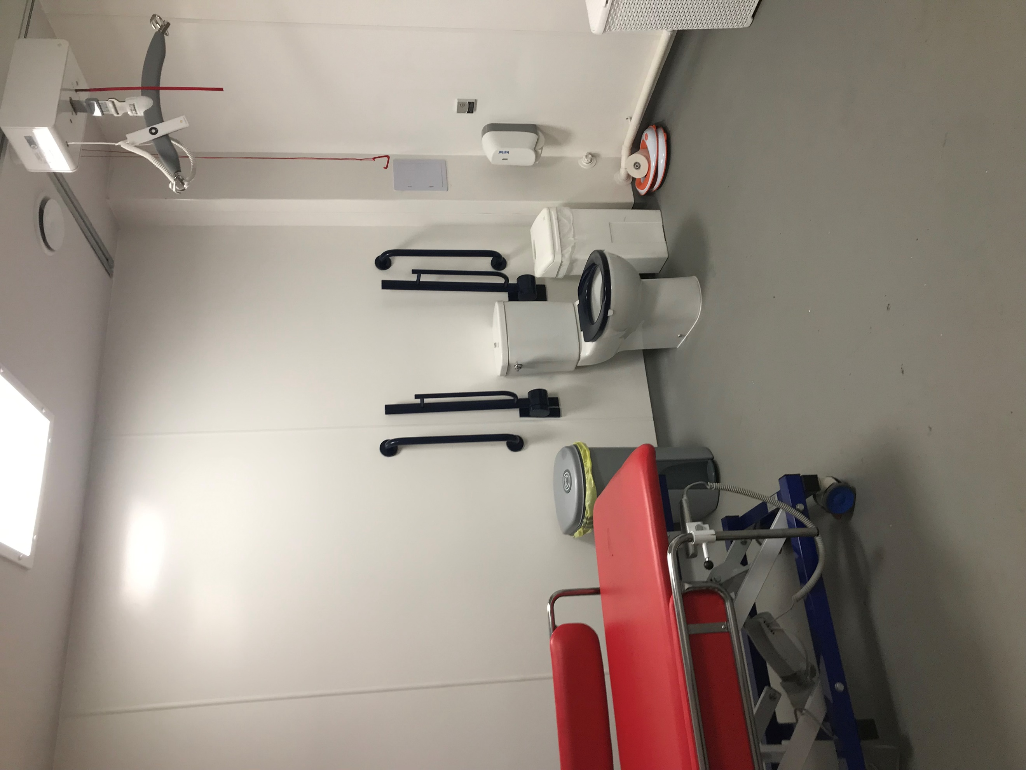

Medical room

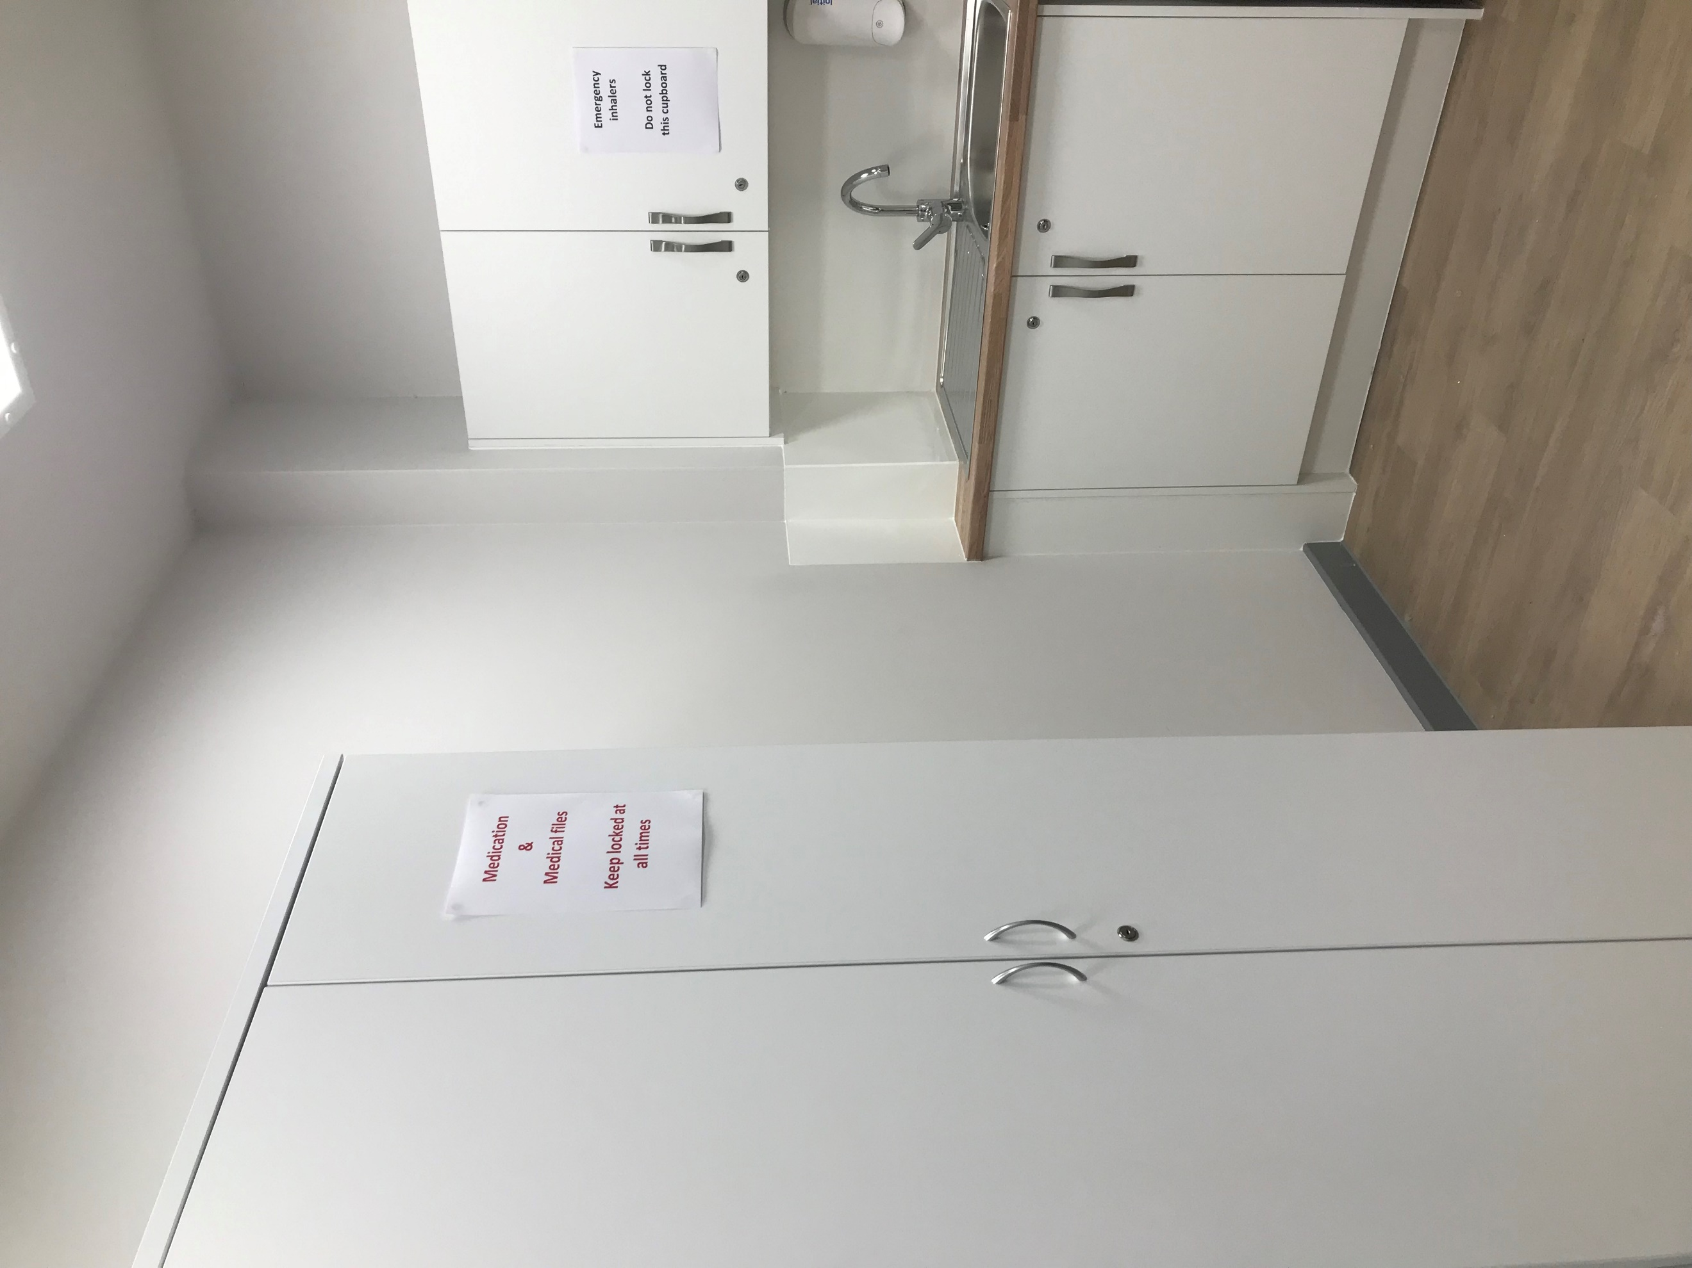

Support
The first point of contact is the class teacher. Teachers have overall responsibility for the welfare of the pupils in their class. They are supported in this role by the senior leadership team and a range of other professionals; we are committed to multi-agency working to ensure the needs of the whole child are met. Class teachers are supported by teaching assistants. Care assistants are employed to support the personal needs of pupils.
All pupils have a care plan which identifies personal care needs, dietary requirements and administration of medication where appropriate.
The academy has access to advice and support from universal school nursing services where needed. Professionals from other agencies such as physiotherapy, occupational therapy and Speech and Language support visit the academy on a regular basis. These professionals support individual pupils offering advice and training to staff.
Discovery Special Academy works closely with the following agencies:
- Middlesbrough SEND team
- Redcar and Cleveland SEND team
- Stockton SEND team
- Educational Psychology
- Speech and Language
- LD CAMHS
- Occupational therapists
- Physiotherapists
- Play therapist
- Social services
- Community nursing
- REACH
- Harbour
- VI/HI services
- Pupils Looked After
- Orthotics
- Continence
- Wheelchair clinic
- Dieticians
- Ethnic minority team

Our Safeguarding, SEND and Inclusion Manager, in partnership with our Pupil and Family Support Advisor, provides support to parents, liaises between home/academy and monitors attendance. The academy works closely with Social Services at all levels. Parent coffee mornings, with workshops/drop-ins by outside agencies (such as Citizens Advice Bureau) are held half termly. We have clear referral routes to external agencies which include the Sensory Teaching Advisory and Resource Service (STARS HI & VI), Social Care, CAMHS, Forget me Not, Banardos, Daisy Chain, Early Help, Housing, Grants and Benefits. In addition, support and guidance from charitable organisations are signposted.
Home/academy communication books are used regularly. A newsletter is sent home each term and assessment information is shared. We also use an App called Dojo to celebrate the pupil’s success.
The pastoral team meet regularly to ensure the pastoral needs of pupils are met. . ELSA support is provided for pupils based on need. A child counsellor is on site two days per week. Pupil voice is encouraged in all areas and there are regular junior leadership team and Eco Warrior meetings (where appropriate). Pupils are informed about what bullying is and ways in which it can be dealt with. We log all incidents of bullying and although this is extremely rare, there is an option for restorative justice sessions.
Pupils who are Looked After have access to all of the resources open to other pupils and in addition, regular review and monitoring meetings are held. We collect data on progress and attendance to ensure their performance is line with their peers.
Parental involvement
Parents are always encouraged to support their child’s learning at home. The academy delivers Early Bird, Early Bird Plus and Teen Life parenting courses and other parental workshops are held during the academic year. Parents are invited termly to open events to meet staff and look at pupil’s work, as well as attending parent/teacher meetings and receiving a detailed pupil report. Discovery regularly invites parents to share a range of events and activities which include performances, celebrations, concerts, coffee mornings, fairs and exhibitions. Parents are also invited to the annual EHCP review meeting and are fully involved in updating EHC plans.
Staff training
All teachers have qualified teaching status. We have a comprehensive induction programme for all staff including an extensive training plan. The majority of staff are first aid trained. All staff receive training in dysphagia (feeding and swallowing), administration of medication, and asthma and epilepsy (including administering emergency medication for epilepsy). They are also trained in positive handling, manual handling, safeguarding, PREVENT, GDPR and fire awareness. Staff training is ongoing to ensure we meet the educational needs of all our pupils and stay up to date with current research into teaching and learning. As part of Tees Valley Education Trust, staff share best practices from four academies as well as having access to our own central improvement team. Staff access training relevant to their roles and career stage, for example, middle leadership training or subject based training. All staff receive at least 5 days CPD per year.

Activities outside of the academy
Discovery are committed to providing opportunities for pupils to have equal access to an enriched and extended curriculum. A variety of activities are provided in the academy such as sensory integration, rebound therapy, art, dance, music, cookery. Trips to local theatres, galleries, historic sites, parks, etc. are part of the curriculum too. We also provide many opportunities at the academy to widen cultural experiences, such as visiting musical groups or ZooLab, for example. The academy has two minibuses to allow ease of access to a wide variety of opportunities and to reduce the costs of trips and visits to families. We will only ever ask for entrance fees to the places we visit if there is a charge.
Our pastoral team will keep parents up to date with suitable activities happening in the local area including after school and holiday clubs through the website, texts and newsletters.
Transition
Transition arrangements are made on an individual basis for each pupil and in discussion with parents and professionals from previous provisions; this is to reduce pupil (and parent!) anxiety levels. Admission for pupils is usually in September into Reception but can occur at various stages of their education. For all, we ensure a comprehensive transition programme which includes visits from the senior leadership team to meet the new pupils, and regular visits by the new pupils to meet us in the academy. Parents are welcomed to look around the academy and attend a coffee morning/afternoon in order to meet the team who will be working with their child and gather vital information.
Likewise, when a pupil transitions to another provision, arrangements will be made to best suit the child and will be done collaboratively with parents and all professionals involved.
Transport
Home to academy transport is provided for all eligible pupils by the local authority. The majority of pupils travel to and from the academy in a mini bus or taxi and are accompanied by a passenger assistant/escort.
Further details regarding transport can be obtained by:
Middlesbrough transport department (01642) 353447
Redcar & Cleveland transport department (01642) 444973
Stockton transport department (01642) 528779 or (01642) 527117
SEND resources
The academy receives base funding for each pupil in the academy and a ‘top-up’ element based on the pupil’s personal level of need. Resources are allocated according to the assessed need and is reviewed on a regular basis.

Linked policies & documents (all available at www.discoveryspecialacademy.org.uk)
SEND Policy
Admissions Policy
Attendance Policy
Child Protection and Safeguarding Policy
Positive Behaviour Policy
Equality Policy & Equality objectives
Accessibility Plan
Health & Safety Policy
Supporting pupils with medical needs & life threatening illness Policy
Intimate Care policy
Graduated Response
Pupil Premium Grant policy
Other policies and guidance documents
DfE – Supporting pupils at school with medical conditions (December 2015)
DfE SEND Code of Practice (2014)
DfE School Admissions Code (2014)
Pupils & Families Bill (2013)
Further information
Middlesbrough council website is www.middlesbrough.gov.uk
Middlesbrough Special Educational Needs Service (01642) 201831
Redcar and Cleveland Council website is http://www.redcar-cleveland.gov.uk
Redcar and Cleveland Special Educational Needs Service (01642) 304561/304503

Local Authority & Health Authority
Middlesbrough Council Pupils with Disabilities Team 01642 579160
Redcar & Cleveland Council Pupils with Disabilities Team 01642 771500
Middlesbrough LA SEN Team 01642 201381
Redcar & Cleveland LA SEN Team 01642 774774
Middlesbrough LA Parent Partnership Officer 01642 201872
Redcar & Cleveland LA Parent Partnership Officer 01642 444527
The Cleveland Child Assessment Unit 01642 729972
Service for Pupils with Visual Impairment 01642 354353
Service for Pupils with Hearing Impairment 01642 354353
Middlesbrough Welfare Rights Service 01642 729242
Redcar & Cleveland Welfare Rights Service 01642 771166
Physiotherapy / Occupational Therapy Service 01642 774774
Speech & Language Therapy Service 01642 944488

Charities & support organisations
In Control 01564 821650
Contact a Family 0808 808 3555
Whizz Kidz (info@whizz-kidz.org.uk) 020 7233 6600
Eston Salvation 01642 440834/01287 636192
Council for Disabled Pupils 0207 6088700
The Parents Carers Alliance (R&C www.TPACA.co.uk) 01642 774774
Parents 4 Change (Middlesbrough) 01642 774774
MAIN Project (Autism support) 01642 608012
SCOPE 0808 800 3333
Mencap 0808 808 1111
Disability Rights UK 0330 995 0404
Family Action 020 8519 2122
MIND (Mental Health) 020 8519 2122
Barnado’s (North East) 0191 240 4801
Forget Me Not (Teesside Hospice Child Bereavement) 01642 811063
I-Can (Pupils’s Communication) 020 7843 2544
Daisy Chain 01642 531248

