

Auxiliary Support Assistant
Discovery Special Academy
Job Ref DSA377



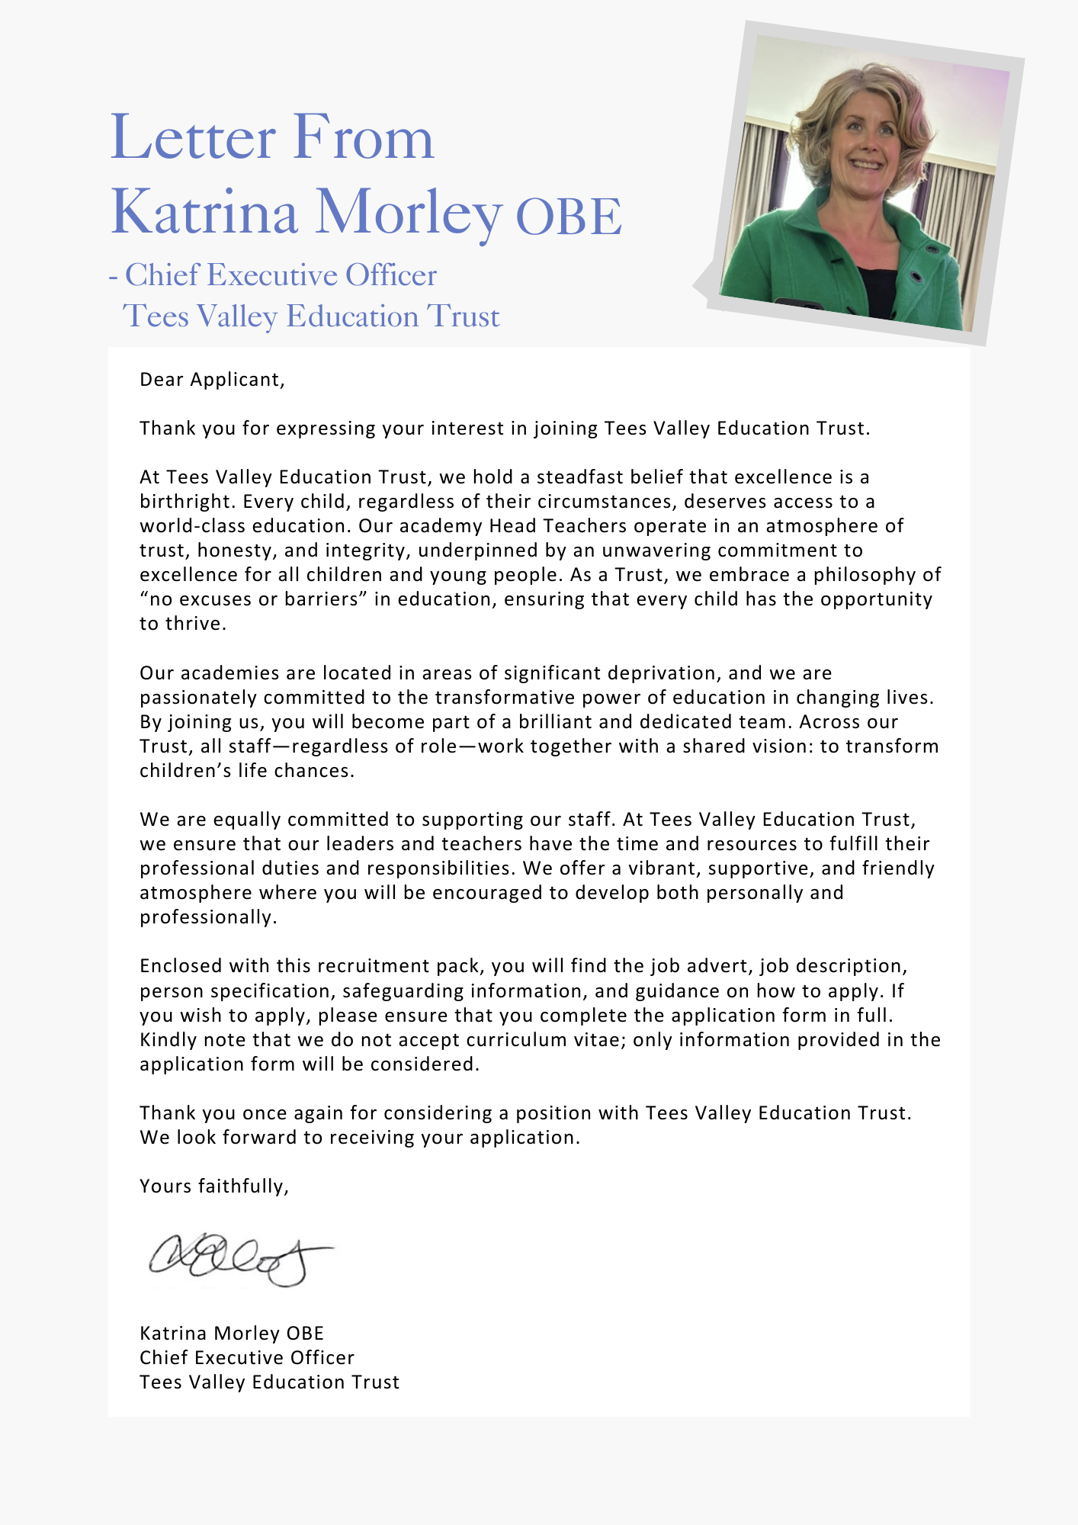

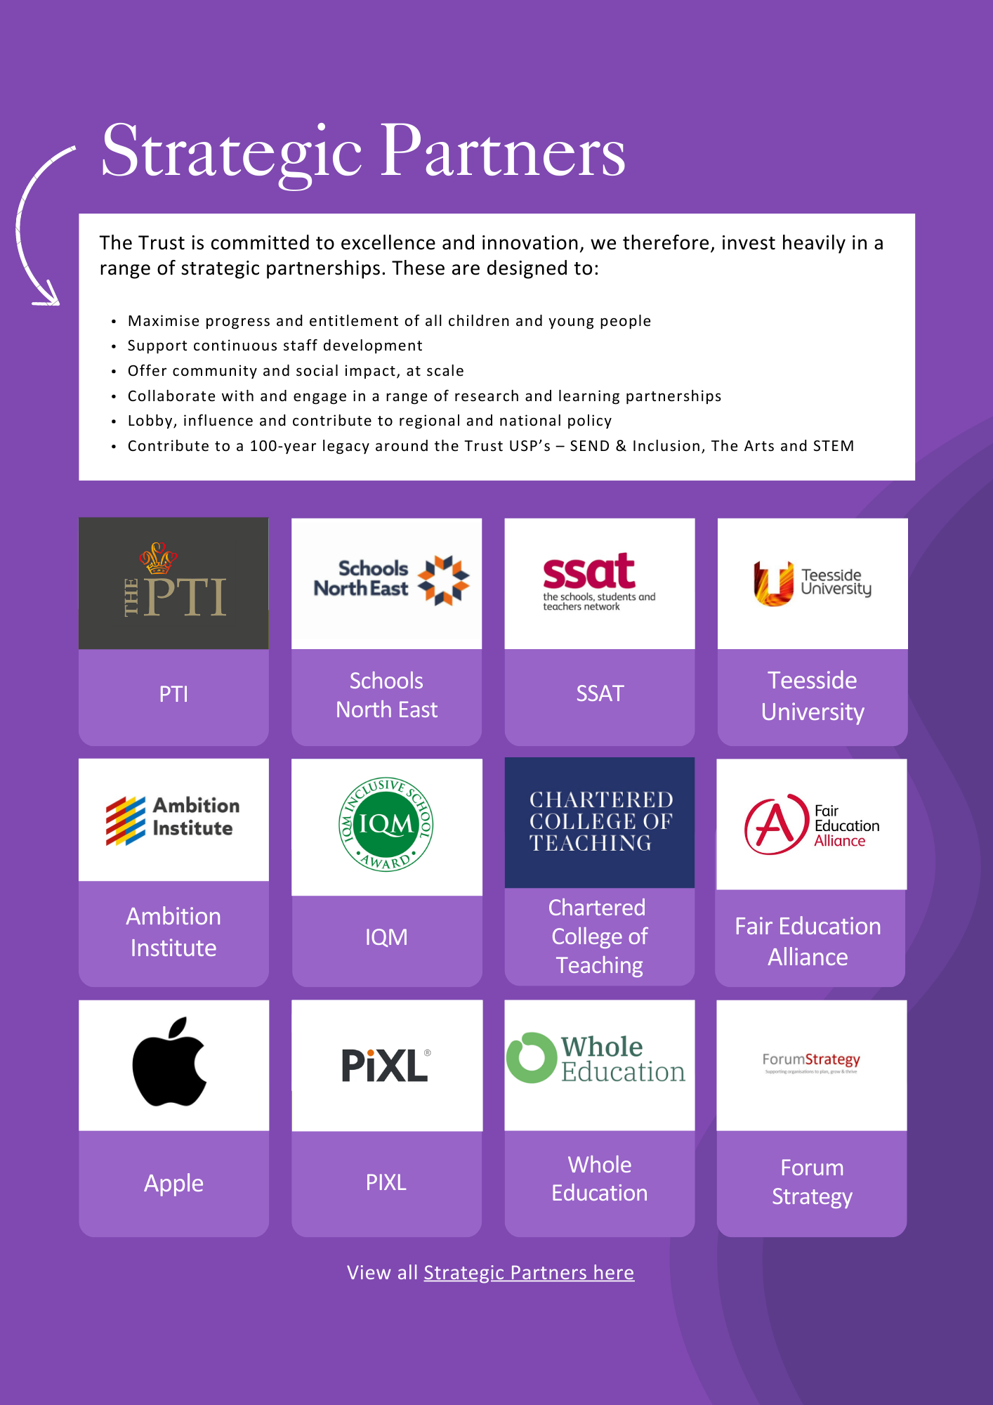



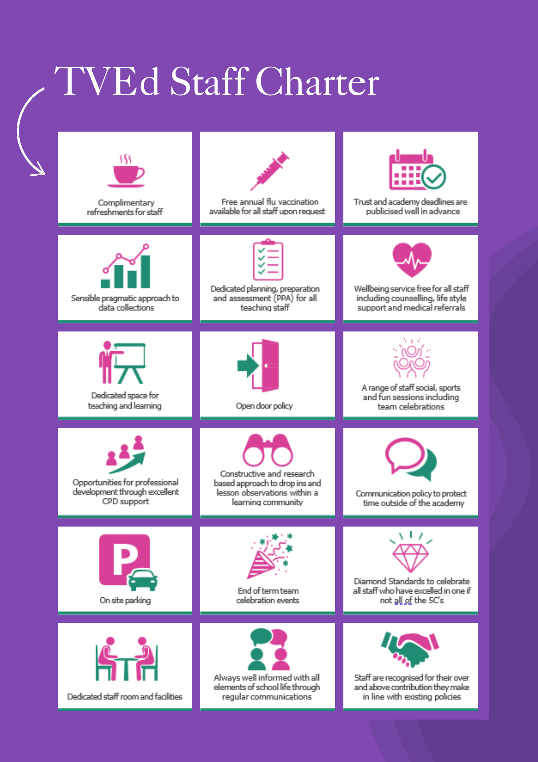

ADVERTISEMENT

Auxiliary Support Assistant
Status: Permanent
Required: 1.9.2025
Salary: (£12.71 per hour) = 15 hrs
Hours: 15 hours per week
Reporting to: Head of Academy
Academy: Discovery Special Academy

About the Trust
The Trust was established in 2015 and provides education and enrichment activities to more than 1100 children across five Academies, located in Middlesbrough and Redcar and Cleveland local authority areas. Academies within the Trust are:
- Brambles Primary Academy (2 to 11 years),
- Discovery Special Academy (3 to 16 years),
- Dormanstown Primary Academy (3 to 11 years),
- Pennyman Primary Academy (2 to 11 years), and
- Wilton Primary Academy (3 to 11 years).

About the role we are looking to appoint:
We are seeking to appoint a dedicated and organised individual to provide general support across the academy. This is a varied and flexible role, designed to meet the evolving needs of the academy on a day-to-day basis.
The successful candidate will support across a range of areas, which may include assisting within classrooms, supervising and supporting pupils during less structured times of the day, and helping to maintain shared spaces, resources, and learning environments. The role will adapt as required to ensure the smooth and effective running of the academy.
The postholder will play an important part in contributing to a positive, safe, and well-organised environment for pupils and staff. Responsibilities may vary depending on operational priorities, and flexibility will be essential.
The ideal candidate will be reliable, proactive, and capable of managing multiple tasks. They will respond positively to changing needs and work collaboratively with colleagues to support the overall functioning and success of the academy.

What we are looking for:
We are looking for people who have enthusiasm, commitment and dedication to children and young people with a range of complex needs.

What the Trust will provide the successful candidate:
- A workplace where all staff are valued and treated with respect as outlined within the Trust’s Diamond Standards
- A passionate, enthusiastic and supportive Leadership Team
- A listening and learning organisation where all staff are encouraged to be curious and share ideas for the Trust/academies/team to improve
- Hard working, committed and dedicated staff who strive to gain the best outcomes for all children across the Trust’s academies
- Dedicated approach to children’s learning to encourage them all to be the best they can be
- Career enhancement opportunities within areas of interest as well as supporting ongoing professional development and training specific to job role
- Dedicated line manager to discuss work streams and capacity
- Free access to the Trust’s Wellbeing offer, which includes counselling, access to GP, Mindfulness and so much more.
- Free parking
- Enrolment into the local government pension scheme
- All support contracts are employed on National Joint Council (NJC) for local government services (also known as Green book)
- Benefits of the Trust’s Staff Charter which can be found at TVED Staff Charter.

Safeguarding requirements for the role:
Tees Valley Education Multi Academy Trust is committed to safeguarding and promoting the welfare of children. All appointments will be subject to a satisfactory enhanced DBS check.
This post is exempt from the Rehabilitation of Offenders Act 1974 and, therefore, all convictions, cautions and bind-overs, including those regarded as “spent” must be declared. The Trust’s Recruitment of Ex-Offender policy can be requested or visit the Trust’s website.
Applications are invited from prospective candidates who demonstrate that they are able to meet the essential criteria set out in the person specification and who have the vision, values and tenacity to join an outstanding team and help continue the journey towards excellence.

JOB DESCRIPTION
To provide auxiliary support across the academy.
MAIN DUTIES AND RESPONSIBILITIES
- Provide flexible general support across the academy, responding to daily operational
needs
- Assist within classrooms to support teaching and learning activities under the direction
of teaching staff
- Work with individual pupils or small groups to reinforce learning and promote
engagement
- Support pupils during less structured times of the day, including arrival, break,
lunchtime, and departure
- Help prepare, organise, and maintain classroom resources and learning materials
- Ensure shared spaces, cupboards, and learning areas are clean, tidy, safe, and well
organised
- Contribute to maintaining a positive, inclusive, and safe environment for all pupils
- Follow academy policies and procedures, including safeguarding and health and safety
requirements
- Undertake additional duties appropriate to the role to support the smooth and effective
running of the academy

The job holder may be required to undertake additional duties as could be reasonably required in exceptional or emergency situations.
The job holder may be required to work across the academy group.
The job holder will be required to undertake additional training e.g. administration of medication, first aid, Positive Handling.
This job description will be reviewed annually and may be subject to amendment or modification at any time after consultation with the post holder. It is not a comprehensive statement of procedures and tasks, but sets out the main expectations of the Trust in relation to the post holder’s professional responsibilities and duties.

Elements of this job description and changes to it may be negotiated at the request of either the line manager.

PERSON SPECIFICATION
QUALIFICATIONS
Have, or be willing to undertake, a range of SEND specific training | A, I, R | E
Have or be willing to undertake training needed for role once appointed. | A, I, R | E
Paediatric first aid | A, I, R | D
EXPERIENCE
Experience of working with children with SEND | A, I, R | E
Experience of working in a school or similar environment | A, I, R | E
Experience of supporting pupils with challenging behaviour | A, I, R | D
KNOWLEDGE, ABILITIES AND SKILLS
Ability to relate well to children | A, I | E
Basic understanding of child development | A, I, R | E
Ability to work as part of a team, following instructions and on own initiative | A, I, R | E
Good communication skills | A, I, R | E
Ability to use time effectively to enable work to be prioritised, accurate and for deadlines to be met | I, R | E
Knowledge of the concept of confidentiality | A, R | E
Understanding of and commitment to safeguarding and protecting the welfare of children and young people | A, I, R | E
Working knowledge of classroom roles and responsibilities | A, I, R | D
First Aid Certificate | A | D

AM (Assessment Method), A- Application Form, I – Interview, R – Reference,
E – Essential, D - Desirable
Important: In the first instance, applications are assessed against the criteria listed above, in addition to overall presentation, use of standard English and grammatical accuracy.

Where applications do not meet the expected standard, they will be rejected before being matched to the person specification.

HOW TO APPLY AND EXPLANATORY NOTES OF THE PROCESS

An application form is attached below. Application packs can be downloaded or printed directly from the Trust website www.teesvalleyeducation.co.uk or requested from the academy. Only applications via the Trust’s official application form will be accepted. Please do not submit a CV as substitute for part or full application form, the information will not be accepted or considered.
If you are submitting your completed application form by e-mail to recruitment@discoveryspecialacademy.org.uk - please be aware the academy cannot be responsible for any formatting anomalies when printing. If you are unable to submit an electronic application form, handwritten or electronic printed copies should be posted or hand delivered to the following address for the attention of Miss Jennifer Duncan.
Discovery Special Academy
Sandy Flatts Lane
MIDDLESBROUGH
TS5 7YN

Shortlisting Process
After the closing date, short listing will be conducted by a panel, who will match your skills/experience against the criteria in the Person Specification. You will be selected for interview entirely on the contents of your application form, so please read the Job Description and Person Specification carefully before you complete your form.
Shortlisted candidates will receive:
- Letter confirming interview details.
- Details of original ID documentation is required to confirm candidates. Photocopies or certified copies are not accepted.
- Criminal Record Self-Declaration Form, which must be brought on the day of the interview in the sealed envelope provided.

References for successful Candidate/s
We may seek references for shortlisted candidate/s and we may also approach previous employers for information to verify particular experience or qualifications before the interview. Any relevant issues arising from references will be taken up post interview.

Interview process
In addition to candidates’ ability to perform the duties of the post, the interview will also explore issues relating to safeguarding and promoting the welfare of children, including:
- Motivation to work with children and young people
- Ability to form and maintain appropriate relationships and personal boundaries with children and young people
- Emotional resilience in working with challenging behaviours
- Attitudes to use of authority and maintaining discipline

Conditional Offer: Pre-Employment Checks
Any offer to a successful candidate will be conditional upon:
- Verification of right to work in the UK
- Receipt of at least two satisfactory references (if these have not already been received)
- Verification of identity checks and qualifications
- Satisfactory enhanced DBS check
- Verification of professional status such e.g. QTS Status, NPQH (where required)
- Satisfactory completion of a Health Assessment
- Satisfactory completion of the probationary period (where relevant)
- Where the successful candidate has worked or been resident overseas in the previous five years, such checks and confirmations as may be required in accordance with statutory guidance.
Please contact the academy office on 01642 2248333 if you would like to arrange a visit.
For your information, the recruitment timetable is detailed below:

Closing date: Monday 20th April 2026
Shortlisting date: Friday 1st May 2026
Interview date: Friday 8th May 2026

UK General Data Protection Regulation
Refer to our privacy policy on how we will process your personal data including how you can request to access your personal data via Tees Valley Education website: http://www.teesvalleyeducation.co.uk.

EQUALITIES INFORMATION AND OBJECTIVES STATEMENT
As an academy we ensure that our vision, values and ethos meet the expectations of the equality and diversity guidelines and legislation set out by the Equality and Human Rights Commission. This includes the following 9 protected characteristics:
- Age
- Disability
- Gender Reassignment
- Marriage and Civil Partnerships
- Pregnancy and Maternity
- Race
- Religion or belief
- Sex
- Sexual Orientation

Objectives Statement
- To support children’s sensory, academic and communication skills to enable them to develop holistically.
- To ensure high expectations across all aspects of the academy (as outlined in objective 1) to ensure children make the best progress according to their individual starting points.
- To continue to monitor attendance of all groups of children in the academy.
- To review levels of parental and pupil engagement in learning and academy life, across all activities and ensure equality and fairness in access and engagement.
- To ensure the academy environment is as accessible as possible to pupils, staff and visitors.

E EMPLOYMENT APPLICATION FORM

Please complete all sections of the form fully: CVs will not be accepted. Please note that providing false information will result in the application being rejected or withdrawal of any offer of employment, or dismissal if you are in post. Please note that checks may be carried out to verify the contents of your application form. Please complete the form in black ink.

Vacancy Job Title |  | Job Ref Number

PART 1
INFORMATION FOR SHORTLISTING AND INTERVIEWING
Salutation (Mr, Ms, Miss, Mrs, Dr etc)
First Name:
Middle Name/s:
Surname/family Name:
Contact email address:
Contact telephone number
Social Media Tag names e.g. Twitter/Facebook/Instagram/LinkedIn etc

2. 2. LETTER OF APPLICATION Please enclose a letter of application of no more than 2 A4 pages which details why you are suitable for the post, your experience to date and how this meets the person specification.

3. PRESENT / LAST APPOINTMENT

Name, address and telephone number of last employer/school/academy
Job title
Date appointed to current post
Permanent/Temporary
Full Time/Part Time
Current salary
Notice period

4. FULL CHRONOLOGICAL HISTORY

Please provide a full history in chronological order (most recent first) since leaving secondary education, including periods of any post-secondary education/training, and part-time and voluntary work as well as full time employment, with start and end dates, explanations for periods not in employment or education/training, and reasons for leaving employment.

Job Title | Name and address of school, | Dates |  |  |  | Reason
or Position | other employer, or description of activity | From To |  |  |  | for  leaving
 |  | Mth | Yr | Mth | Yr
1

2

3

4

5

6

7

8

Please enclose a continuation sheet if necessary
5. SECONDARY EDUCATION & QUALIFICATIONS

Name of School/College | From | To | Qualifications Gained (Date and Grade)

6. HIGHER EDUCATION

Names and Addresses of  University or College and/or  University Education Department | Dates  From To | Full or  Part-time | Courses/subjects taken and  Grade | Date of  Examination and  Qualifications Obtained

7. PROFESSIONAL COURSES ATTENDED Please list relevant courses attended in past 3 years.

Subject | Organising Body | Date(s) | Duration

8. OTHER RELEVANT EXPERIENCE, INTERESTS AND SKILLS

9. REFEREES
Give here details of two people to whom reference may be made. The first referee should normally be your present or most recent Headteacher or equivalent person. If you are not currently working with children please provide a referee from your most recent employment involving children. Referees will be asked about disciplinary offences relating to children, which may include any in which the penalty is “time expired” and whether you have been the subject of any child protection concerns, and if so, the outcome of any enquiry or disciplinary procedure. References will not be accepted from relatives or from people writing solely in the capacity of friends.
First referee
Title and Name
Address and post code
Telephone number
Email address
Job Title
Relationship to applicant
Please tick if you do not wish this referee to be contacted prior to interview
(Please be aware that this could delay the interview process)
Second referee
Title and Name
Address and post code
Telephone number
Email address
Job Title
Relationship to applicant
Please tick if you do not wish this referee to be contacted prior to interview
(Please be aware that this could delay the interview process)

PART 2
This section will be separated from Part 1 on receipt. Relevant contents may be verified prior to shortlisting but will not then be used for selection purposes.
10. PERSONAL INFORMATION
Surname or family name
All previous surnames
All forenames
Title
Date of Birth
Current Address
Postcode
Resident at this address since
Home telephone number
Mobile telephone number
Email address
National Insurance Number
Have you ever been subject to a child protection investigation by your employer or the General Teaching Council/Teaching Agency/former Independent Safeguarding Authority? | Yes No  If YES please state separately under confidential cover the circumstances and the outcome including any orders or conditions.
Are you subject to any legal restrictions in respect of your employment in the UK? | Yes No  If YES please provide details separately
Do you require a work permit? | Yes No  If YES please provide details separately
Are there any special arrangements which we can make for you if you are called for an interview and/or work-based assessment? | Yes No  If Yes please specify, (e.g. ground floor venue, sign language, interpreter, audiotape etc).
Are you related to or have a close personal relationship with any pupil, employee, trustee, member or local academy chair? | Yes No  If YES give details separately under confidential cover
TEACHERS ONLY
Early Career Teachers ONLY:  Have you provided evidence of passing the Skills Tests? Please tick or cross | Numeracy  Literacy  ICT (if applicable)
DfE reference number (if applicable)
Did you qualify as a teacher after May 1999? (if applicable) | Yes No  If Yes, in which school was induction completed?
- COMPULSORY DECLARATION OF ANY CONVICTIONS, CAUTIONS OR REPRIMANDS, WARNINGS OR BIND-OVERS

As the job for which you are applying involves substantial opportunity for access to children, it is important that you provide us with legally accurate answers. Upfront disclosure of a criminal record may not debar you from appointment as we shall consider the nature of the offence, how long ago and at what age it was committed and any other relevant factors. Please disclose any unspent convictions, cautions, reprimands or warnings. Please note that the amendments to the Exceptions Order 1975 (2013) provide that certain spent convictions and cautions are ‘protected’ and are not subject to disclosure to employers, and cannot be taken into account. Guidance and criteria on the filtering of these cautions and convictions can be found at the Disclosure and Barring Service. Failure to declare any convictions (that not subject to DBS filtering) may disqualify you for appointment or result in summary dismissal if the discrepancy comes to light subsequently.

Do you have ANY convictions, cautions or reprimands, warnings or bind-overs?
Please tick the relevant box

Yes ◻ No ◻

If the answer is "yes", you must record full details in a separate, sealed envelope marked with your name and 'Confidential: Criminal Record Declaration' and bring this with you on the day of your interview. If you would like to discuss this beforehand, please telephone in confidence to the Headteacher for advice. In accordance with statutory requirements, an offer of employment will be subject to satisfactory DBS clearance.

12. UK GDPR and DATA PROTECTION ACT

The information collected on this form will be used in compliance with the UK GDPR and Data Protection Act 1998. The information is collected for the purpose of administering the employment and training of employees. The information may be disclosed, as appropriate, to trustees, Occupational Health, DfE, Teachers Pensions Agency and local government pensions scheme, Department for Education, pension, payroll and personnel providers including relevant statutory bodies. For further information refer to the trust’s privacy policy via Tees Valley Education website: https://www.teesvalleyeducation.co.uk/.

You should also note that checks may be made to verify the information provided and may also be used to prevent and/or detect fraud.

13. NOTES

a) When completed, this form should be returned in accordance with the instruction in the advertisement for the job or in the applicant’s information pack.
b) Canvassing, directly or indirectly, an employee, trustee, member, local academy chair will disqualify the application.
c) Candidates recommended for appointment will be required to complete a pre-employment medical questionnaire and may be required to undergo a medical examination.
.
14. DECLARATION

I certify that, to the best of my knowledge and belief, all particulars included in my application are correct. I understand and accept that providing false information will result in my application being rejected or withdrawal of any offer of employment, or dismissal if I am in post. I understand and accept that the information I have provided may be used in accordance with paragraph 13 above, and in particular that checks may be carried out to verify the contents of my application form.

_______________________________________
Signature of applicant Date

________________________________________
Print name
This section of the application form will not be available to the shortlisting/interview panel.

PART 3 EQUALITY AND DIVERSITY MONITORING

This section will be separated from part 1 and part 2. Collection of equality information is solely for monitoring purposes to ensure that our policies and procedures are effective. We also collect this data in accordance with the general and specific public sector equality duties under the Equality Act 2010. Any data you enter onto this monitoring form will only be used for monitoring purposes and will not be used in assessing and or scoring your application or during the interview process. This information is kept fully confidential and access is strictly limited in accordance with the UK GDPR and Data Protection Act.

Ethnic Group Workforce
Census Code Please tick
White | WBRI | British English Welsh Northern Irish Scottish
White | WIRI | Irish
White | OOTH | Irish Traveller
White | OOTH | Gypsy
White | WOTH | Other White background
Mixed | MWBC | White and Black Caribbean
Mixed | MWBA | White and Black African
Mixed | MWAS | White and Asian
Mixed | MOTH | Other Mixed background
Asian  or Asian British | AIND | Indian
Asian  or Asian British | APKN | Pakistani
Asian  or Asian British | ABAN | Bangladeshi
Asian  or Asian British | CHNE | Chinese
Asian  or Asian British | AOTH | Other Asian background
Black  or Black British | BCRB | Caribbean
Black  or Black British | BAFR | African
Black  or Black British | BOTH | Other Black background
Other ethnic group | OOTH | Arab
Other ethnic group |  | Write in:
Prefer not to say | REFU

Religion Please tick Disability Please tick
Do you consider that you have a disability?

No religion
Christian (including Church of England, Catholic, Protestant and all other Christian denominations)
Buddhist
Hindu
Jewish
Muslim
Sikh
Any other religion write in
Prefer not to say

Yes
No
Prefer not to say
My disability is:
Please tick
Physical Impairment
Sensory Impairment
Mental Health Condition
Learning Disability/ Difficulty
Long standing illness
Other
Prefer not to say

Sexual Orientation Please tick

Bi-sexual
Gay
Lesbian
Heterosexual
Other
Prefer not to say

Gender Please tick
Female
Male
Transgender
Prefer not to say

Personal relationship Please tick

Single
Living together
Married
Civil Partnership
Prefer not to say

PART 3 HOW DID YOU HEAR ABOUT THE ADVERT?

Please advise how you heard about the advert to help us improve how we advertise in the future. Please select all that apply:

 | Tick |  | Tick
Jobs North East website: |  | Sector 1:
Trust and/or Academy website: |  | Social media inc. X, Instagram, LinkedIn, Facebook etc
Recruitment sites, (please advise which one/s): |  | Recruitment agencies (please advise which one/s):
DfE teaching vacancies: |  | Xentrall:
School North East job: |  | Local or national newspaper e.g. TES (please state which one/s):
Word of mouth: |  | Other (please advise):



